**Case Project**

**Scenario**

Contoso Pharmaceuticals is a medical research company with about 5,000 employees worldwide. They have specific needs for ensuring that medical records and data remain private. The company has a headquarters location and multiple worldwide sites. Contoso has recently deployed a Windows Server and Windows client infrastructure. You have been asked to Complete tasks below

**Objectives**

1. Install a domain called yourname.local on Server core
2. Configure Group Policy and enforce password change to 30 days
3. Install DHCP server,
   1. Create 4 scopes named yourname-TorontoLab, Yourname-TorontoOffice, Yourname-MontrealLab, yourname-montrealOffice (use any Ip range you like)
   2. Create 1 Superscope for Montreal (yourname-Superscope)
   3. Create 1 Multicast scope (yourname Multicast scope)
   4. Create a reservation
   5. Configure options
4. On your domain DNS Server, create forwarder and forward all requests to 8.8.8.8
5. Create a storage pool and a virtual disk
6. Create in ISCSI disk on server 2 and attach it to Server 3
7. Install Hyper-V Role on server 2 and create a virtual machine
8. Install Hyper-V role on server 3 and configure Hyper-v Replica
9. Install and Configure WSUS
   1. Enforce WSUS settings to clients using group policy and remove pause option.

~~~~~~  
Paste your screenshots here

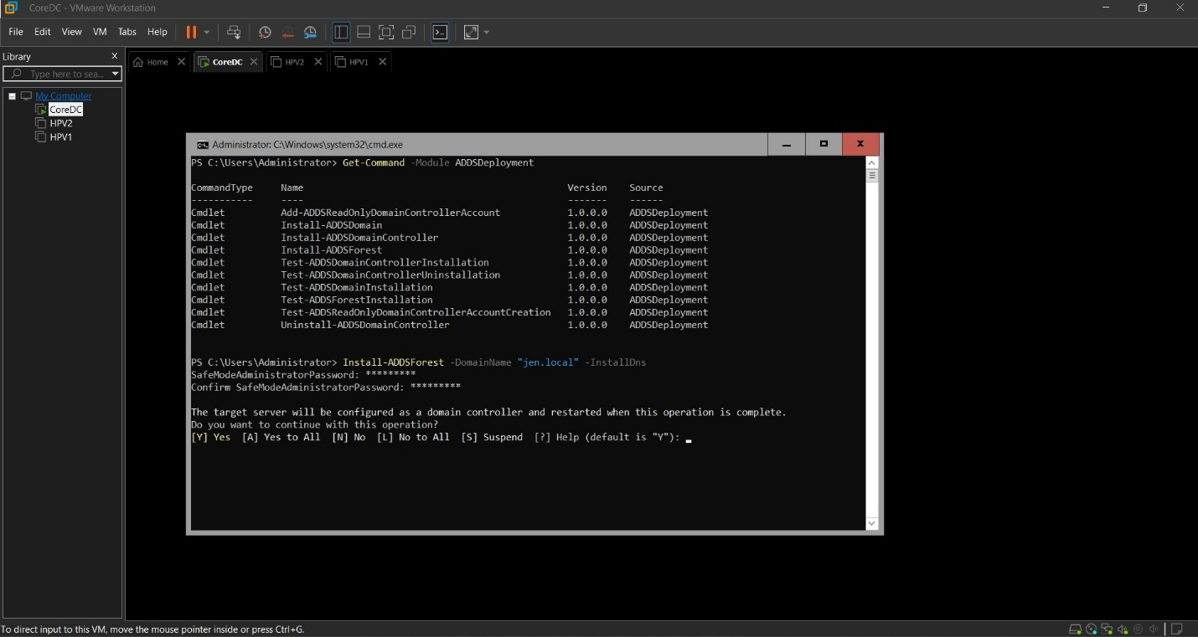

Figure 1Installed Active Directory and Promoted to Domain Controller jen.local

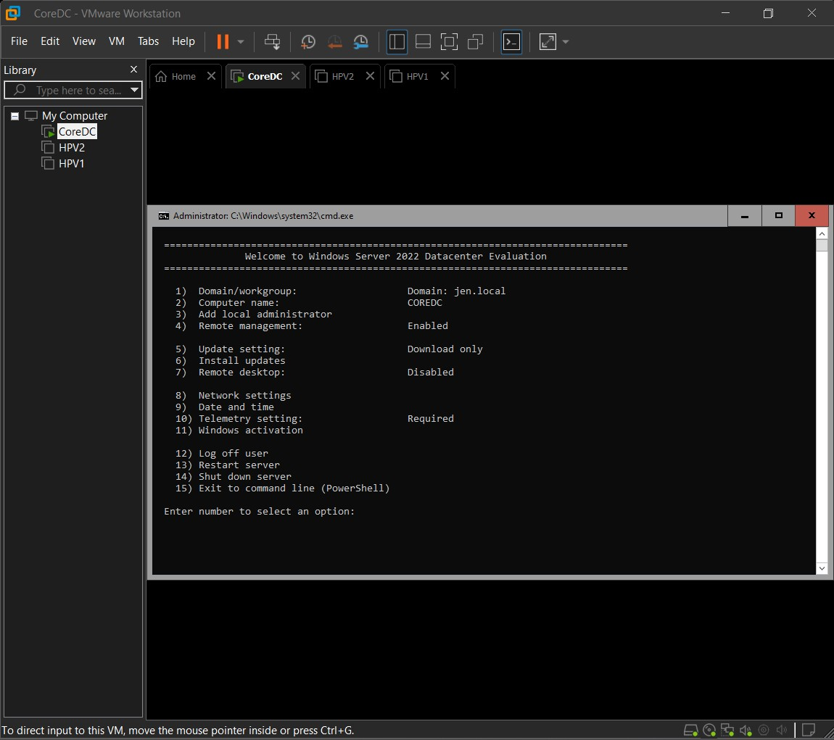

Figure 2Server Core Interface as Domain Controller

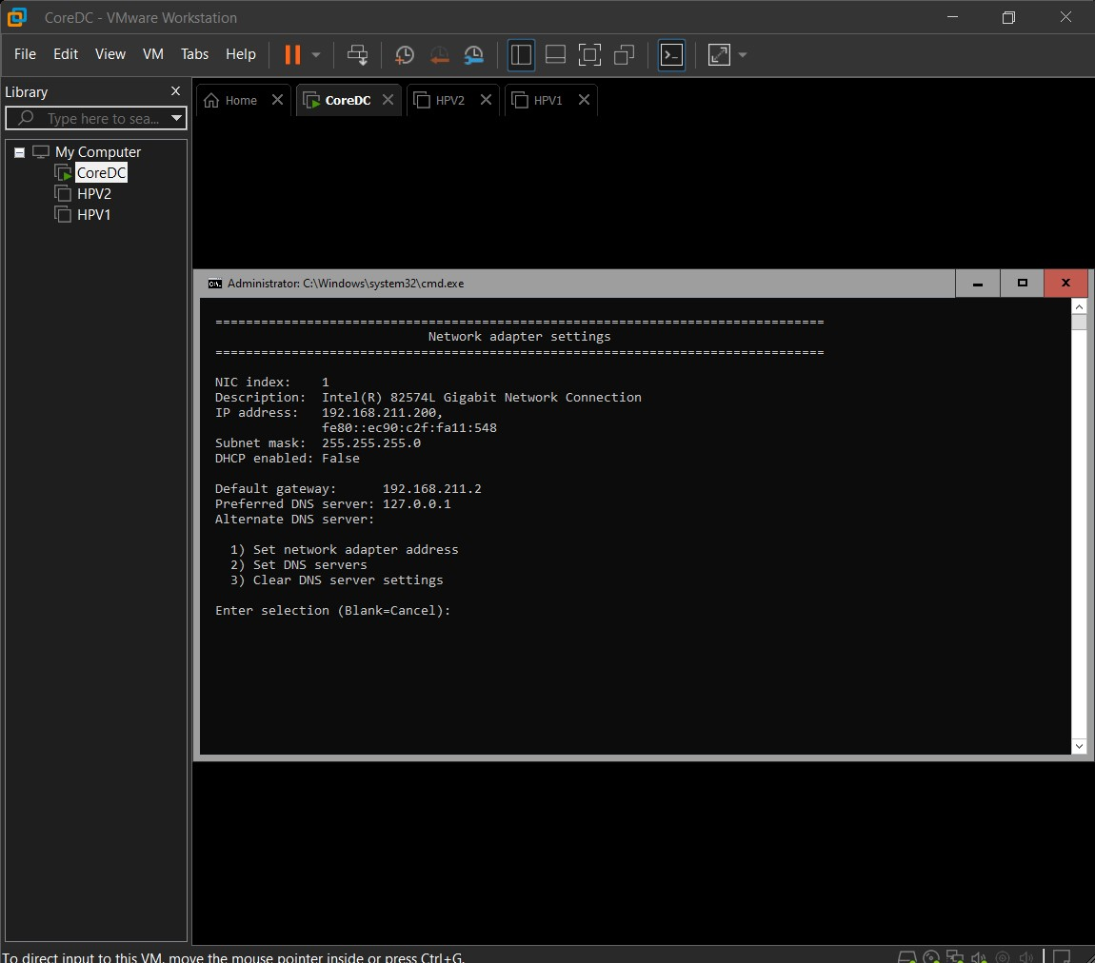

Figure 3 Network Configuration

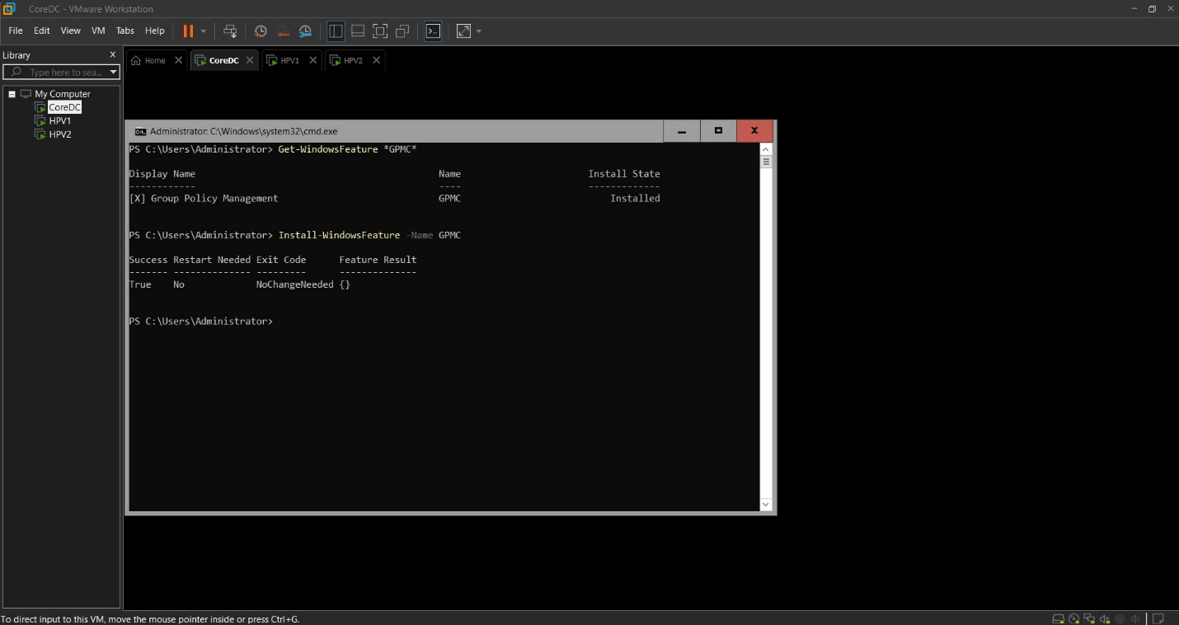

Figure 4 Group Policy Management Console Installed

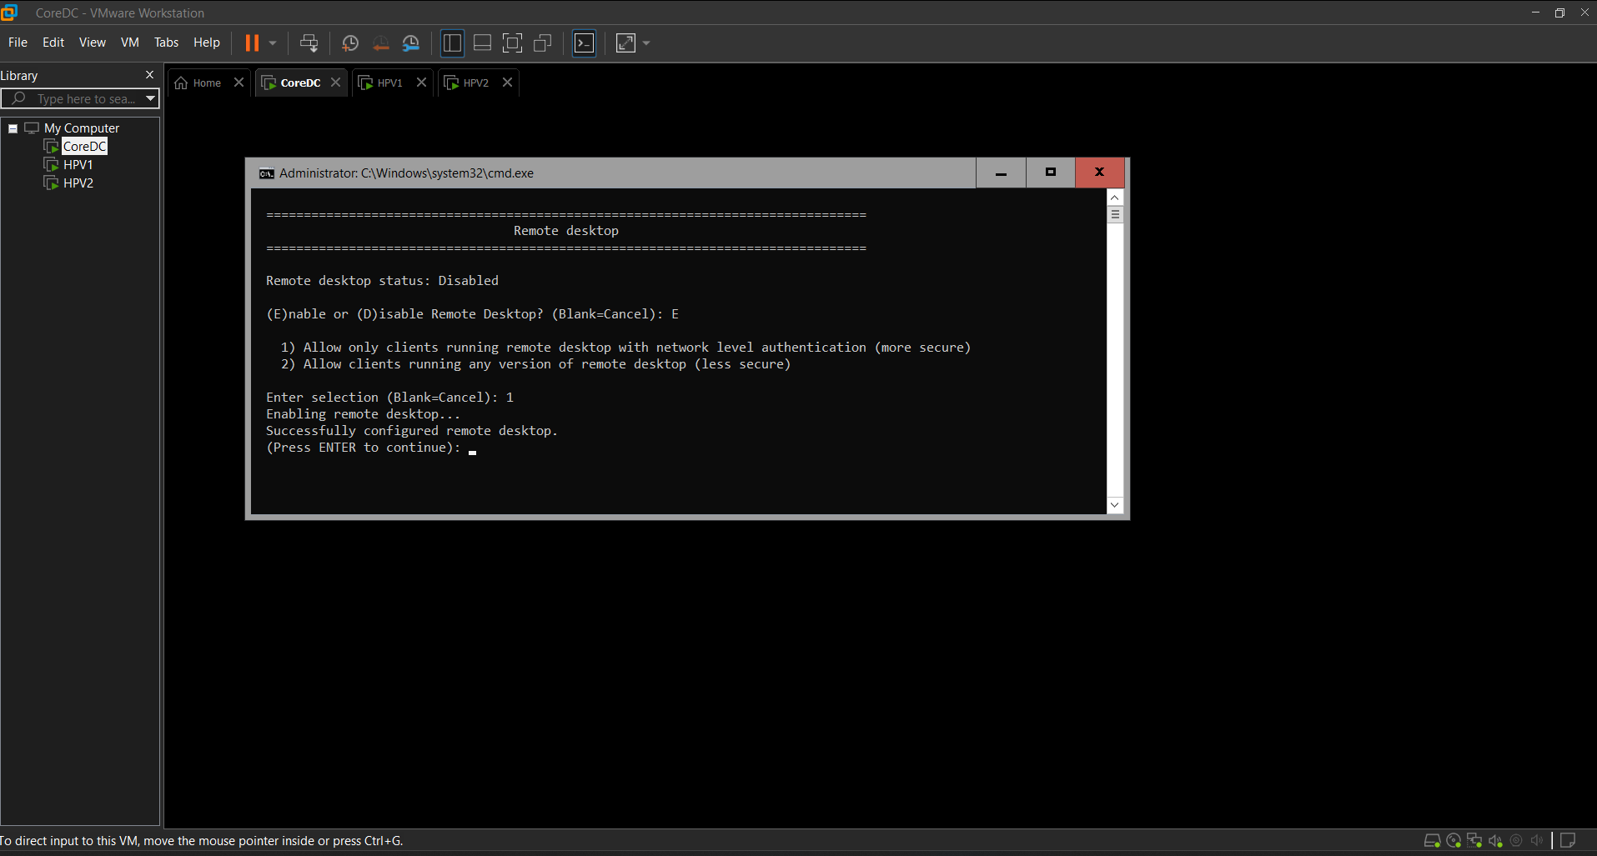

Figure 5Enabled Remote Desktop

Install and Configure a Group Policy Object and enforce Password change to 30 days

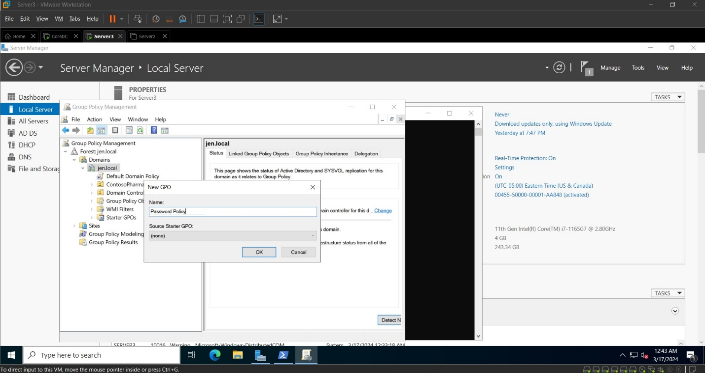

Figure 6: Created new Group Policy Object – Password Policy

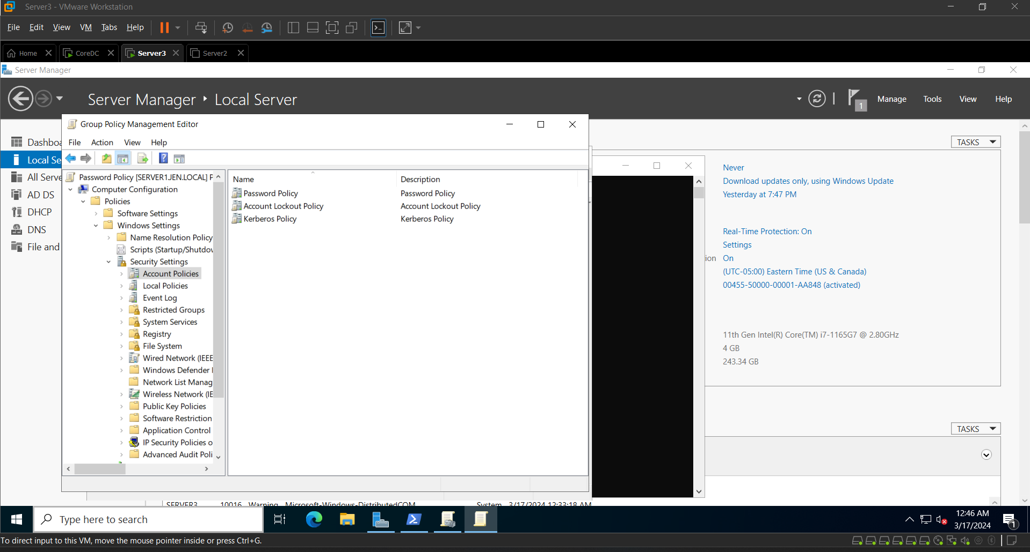

Figure 7 Edit Password Policy

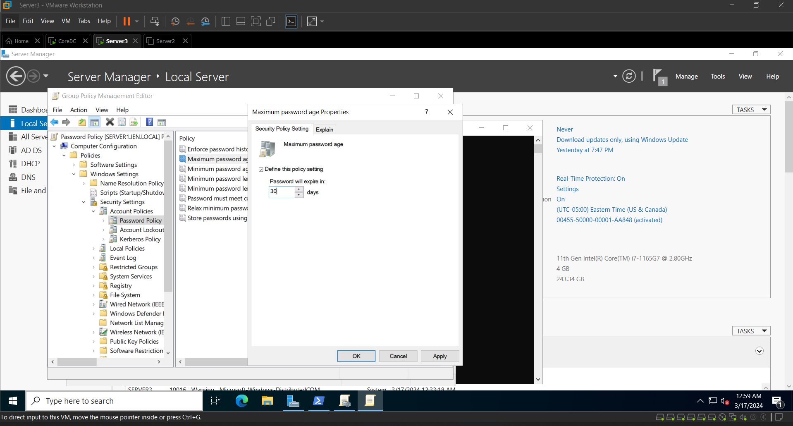

Figure 8 Edit Maximum password properties

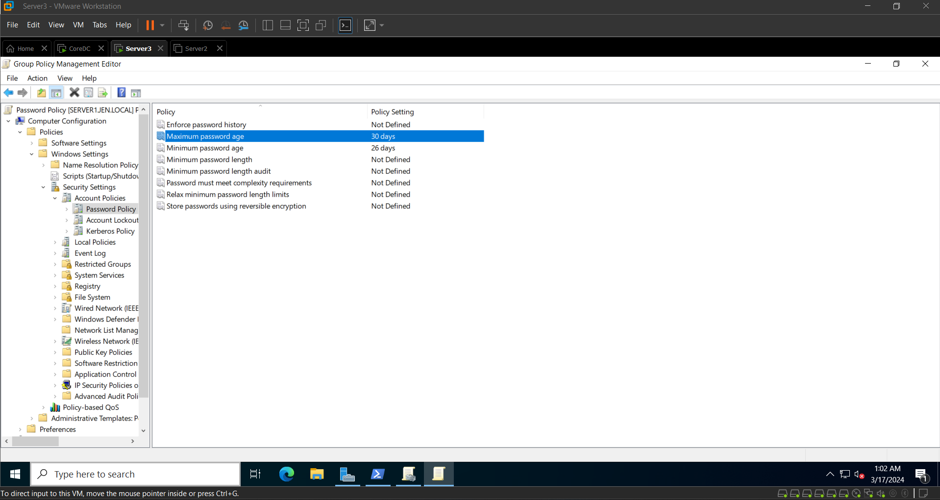

Figure 9 Maximum password age changed to 30 days

## Install DHCP Server

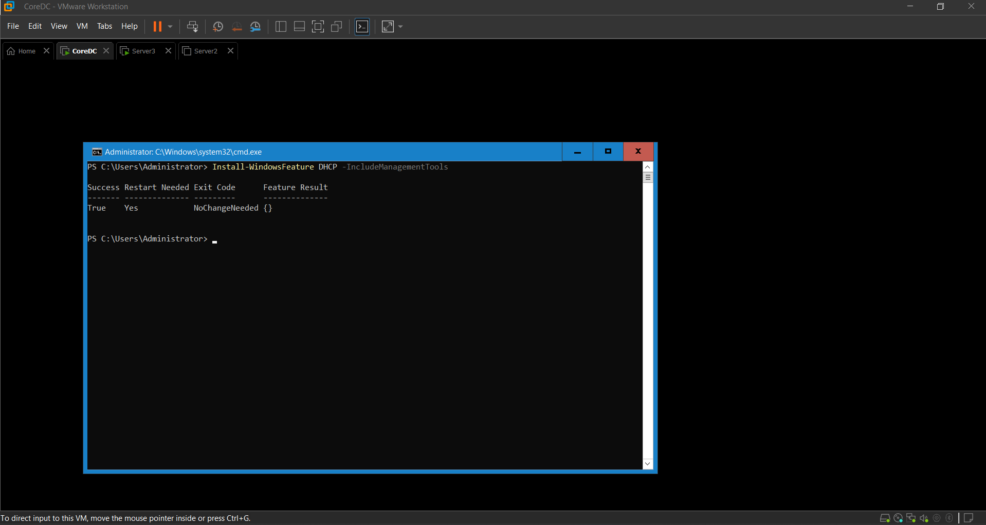

Figure 10: Installed DHCP Server

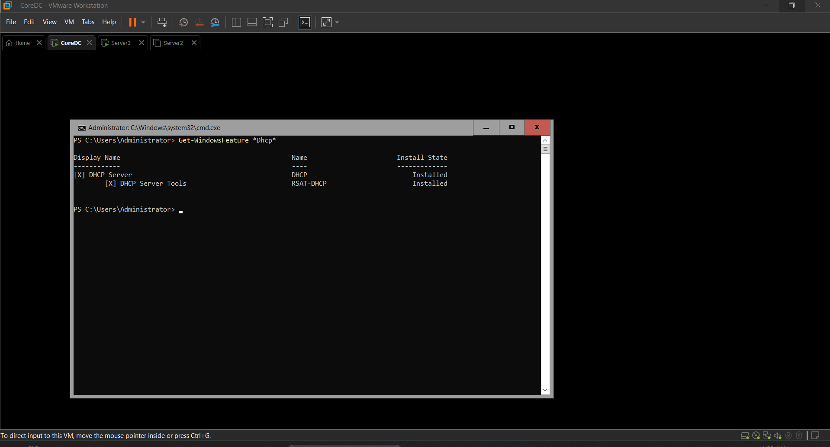

Figure 11DHCP Installed

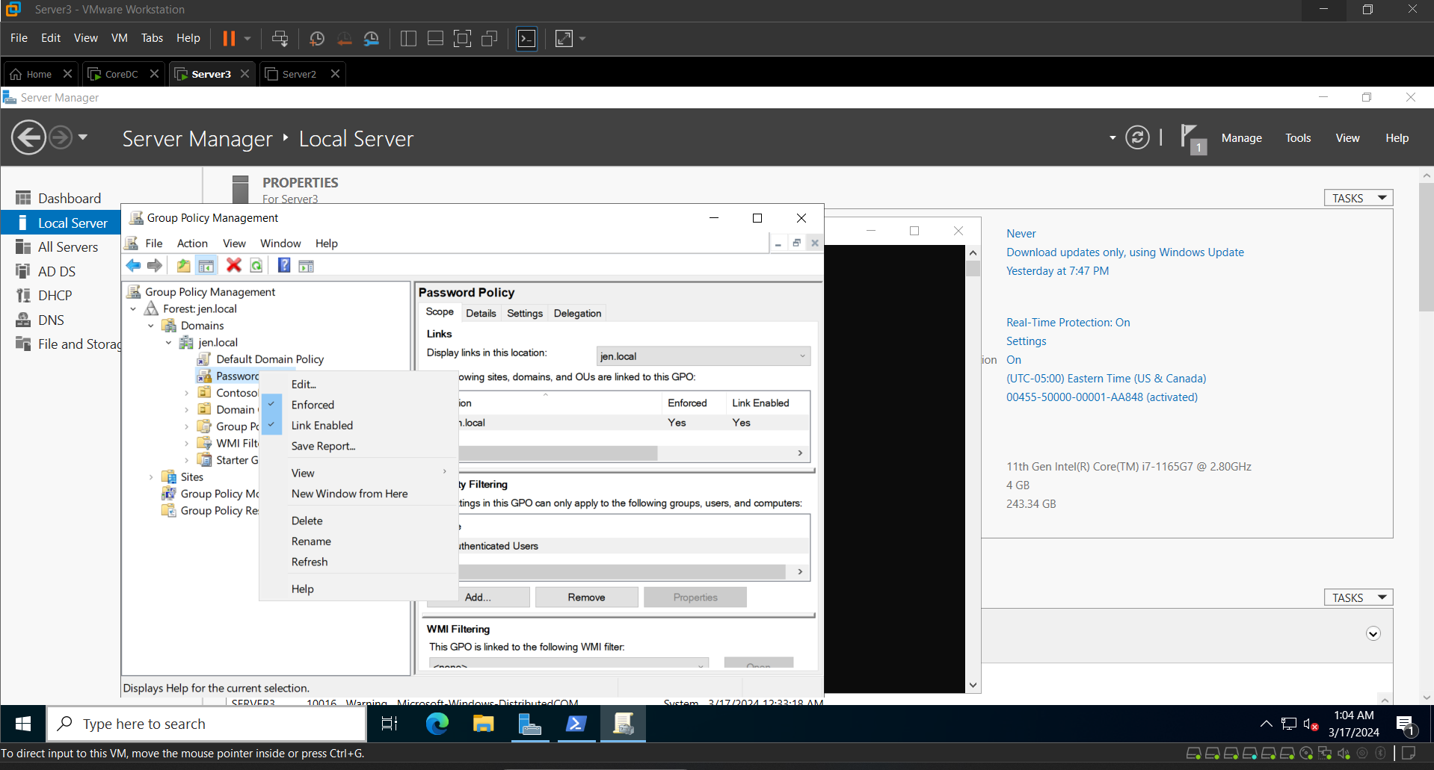

Figure 12 Password Policy Link Enabled and Enforced

## Install and Configure DHCP and DHCP Scope

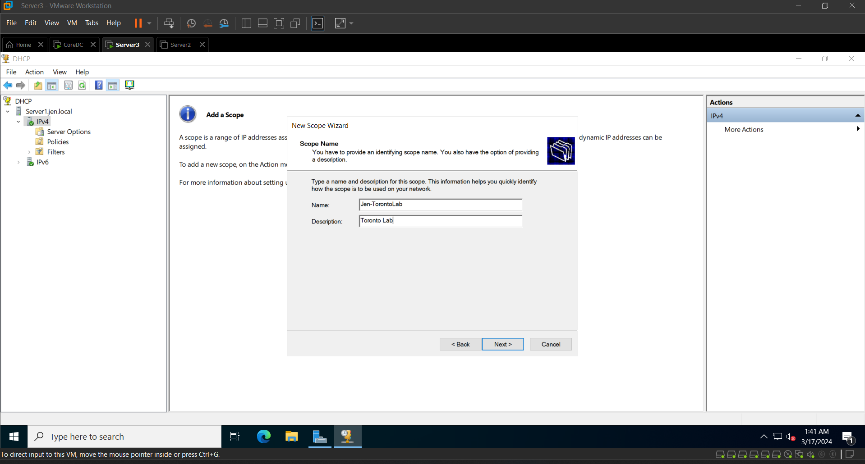

Figure 13 Configure Scope for Jen-TorontoLab

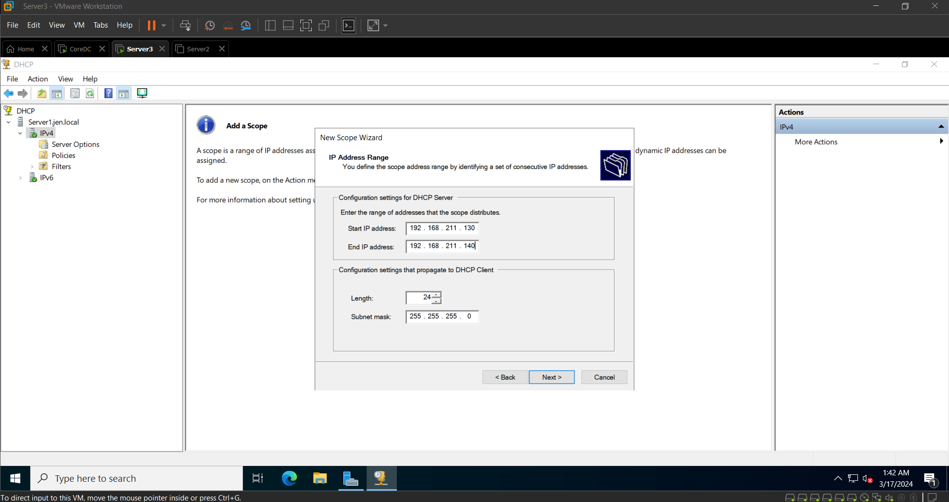

Figure 14 IP StartRange and EndRange for Jen-TorontoLab

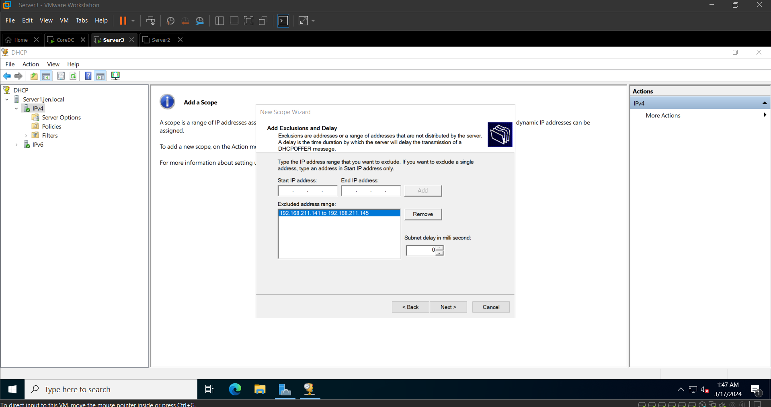

Figure 15: Excluded IP Address ranges Jen-TorontoLab

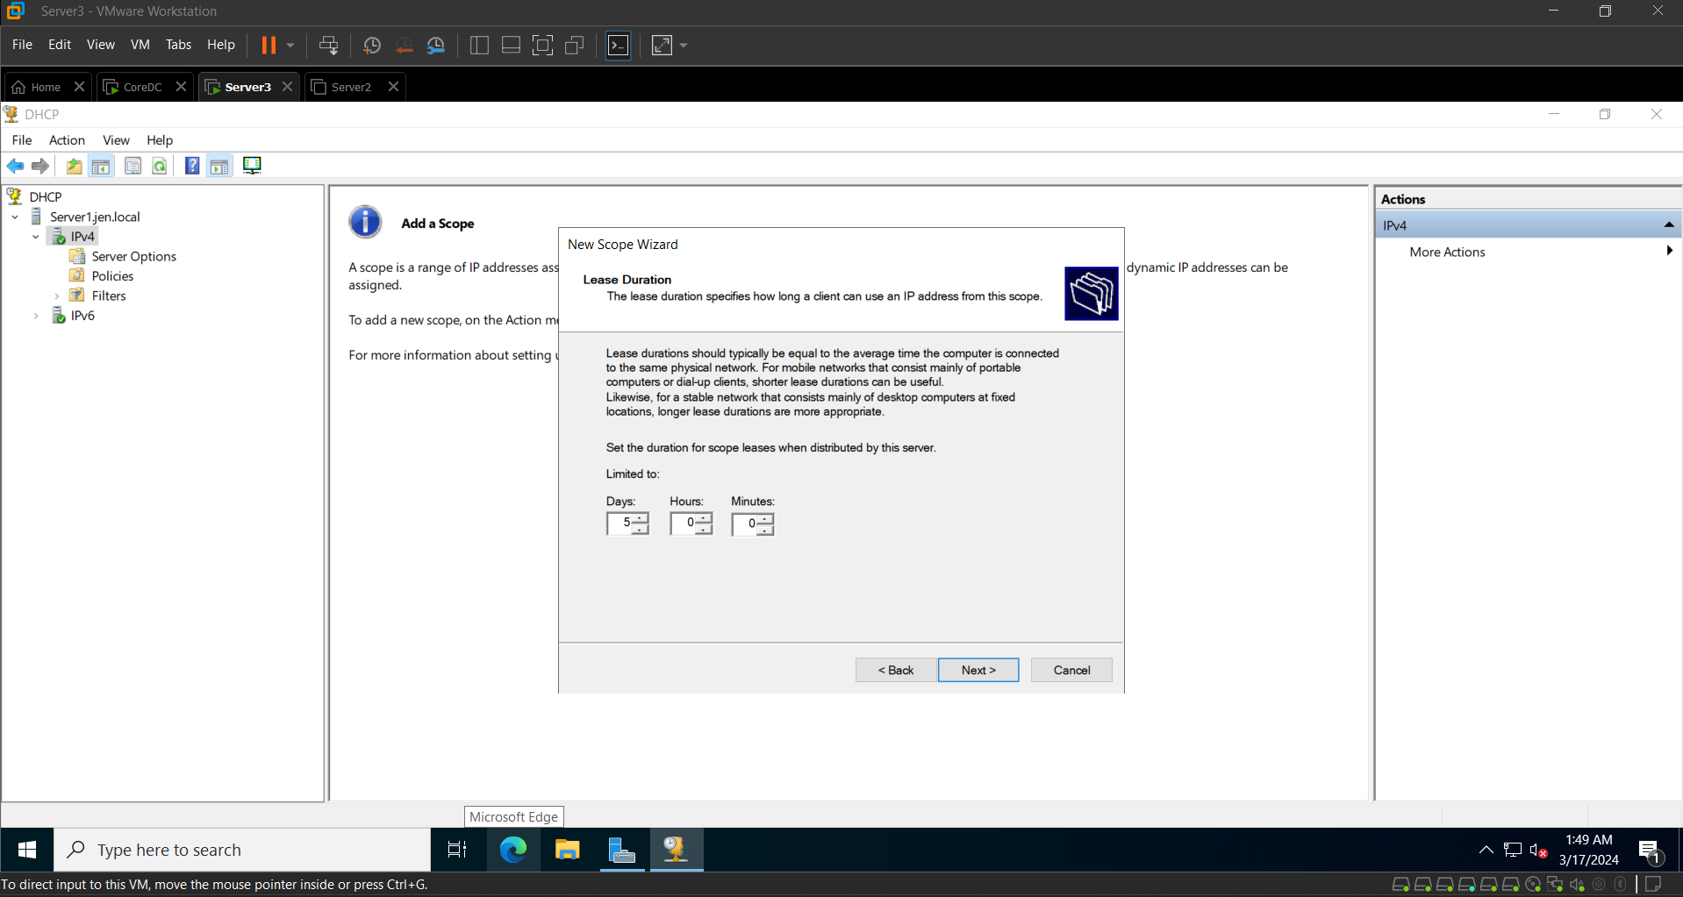

Figure 16: Lease period configured for 5 days

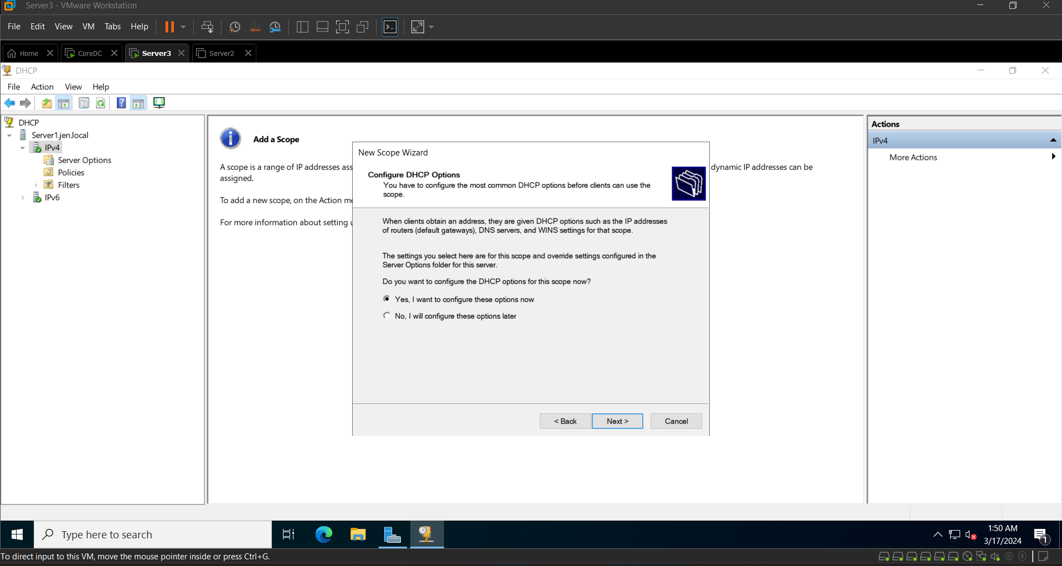

Figure 17: Configuration Time line

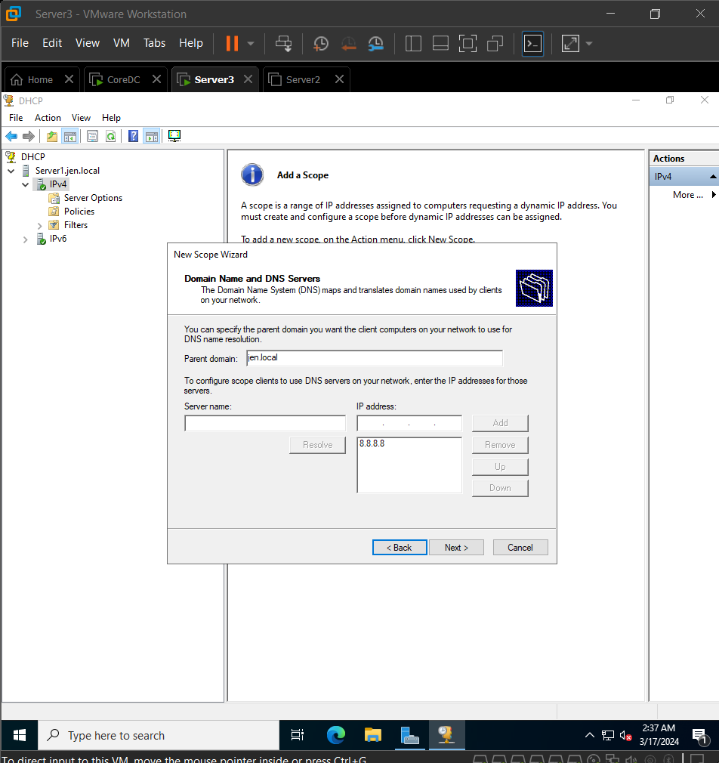

Figure 18: Domain Name and DNS Servers

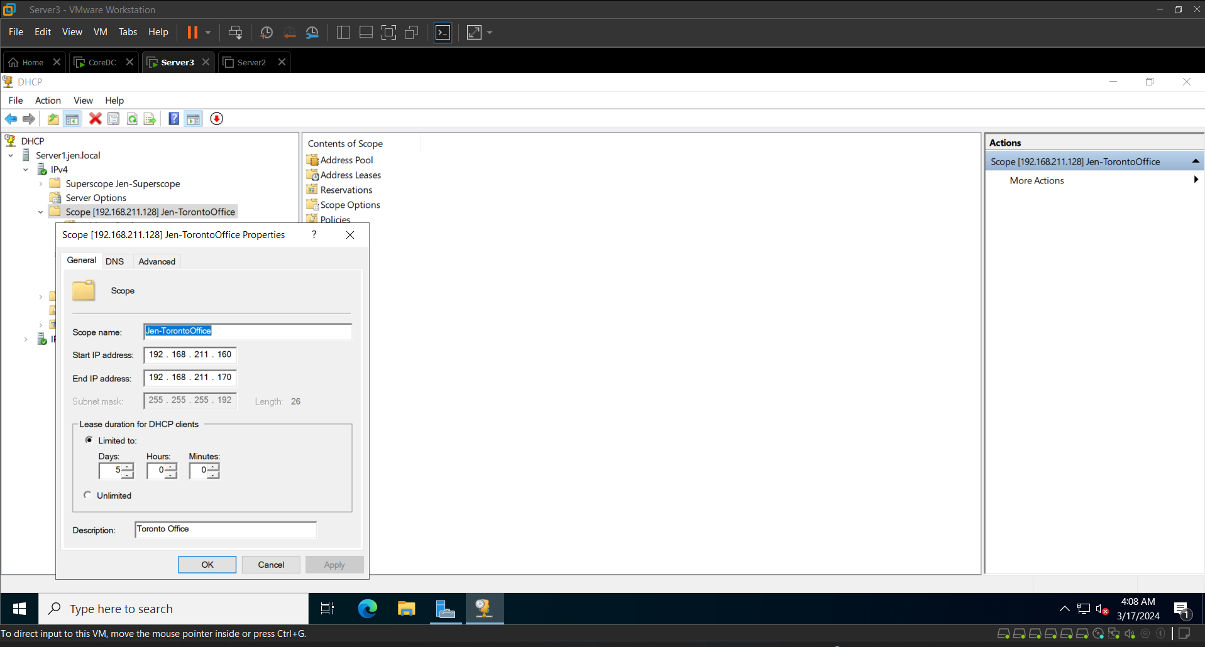

Figure 19: Jen-Toronto Office

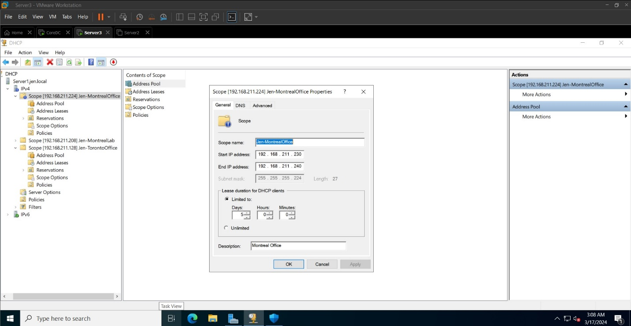

Figure 20: Jen-Montreal Office

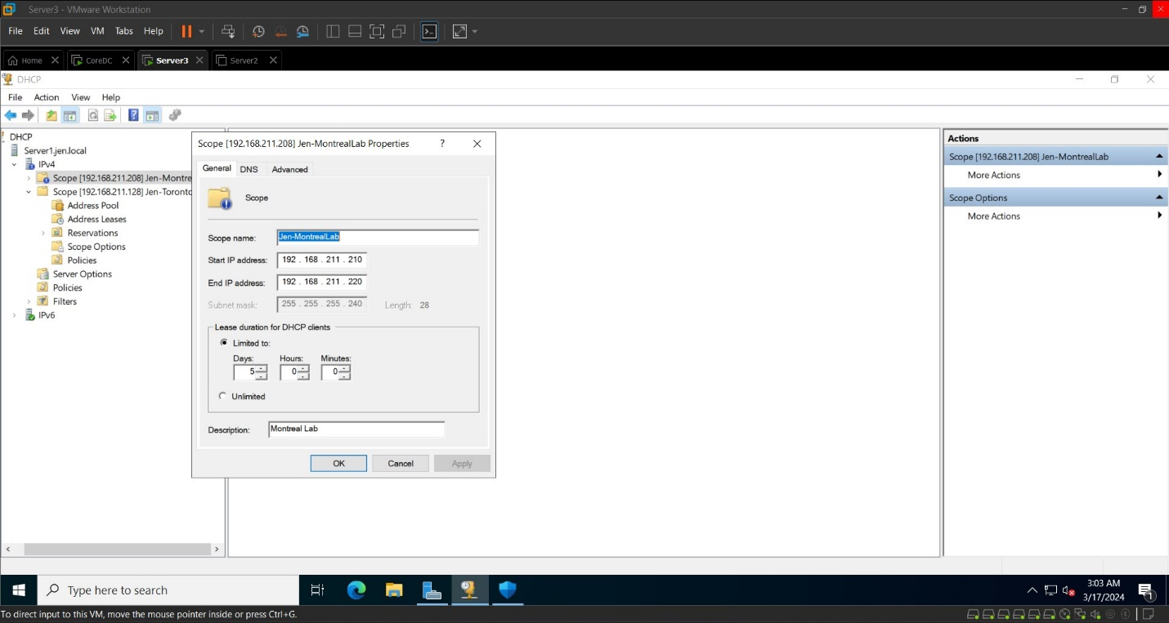

Figure 21: Jen-MontrealLab

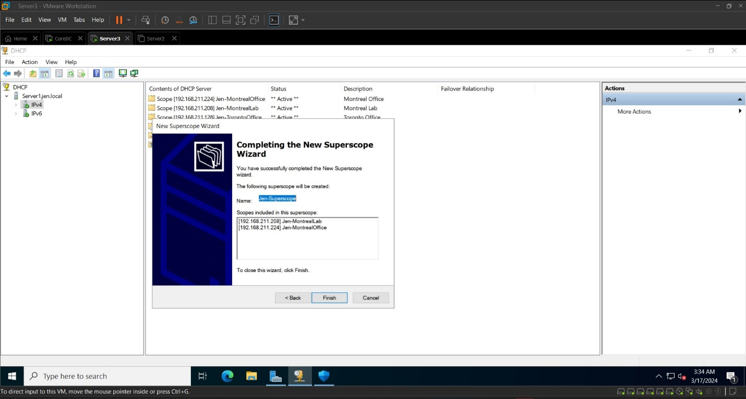

Figure 22: Jen-Superscope-Montreal

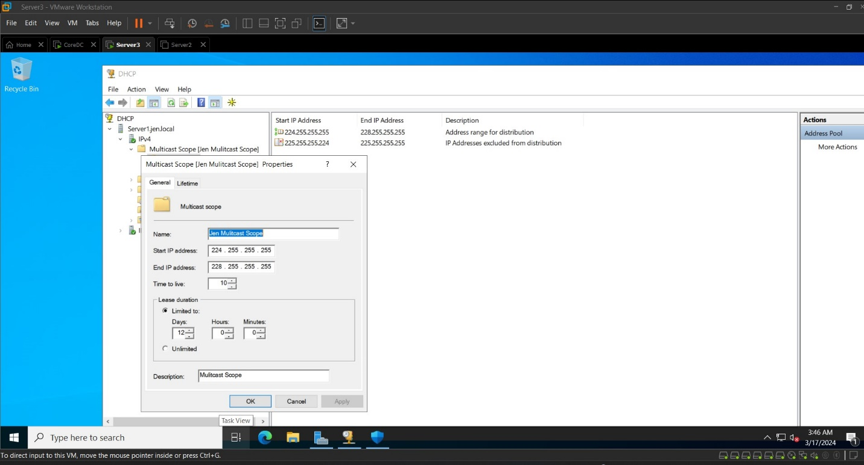

Figure 23: Multiscope

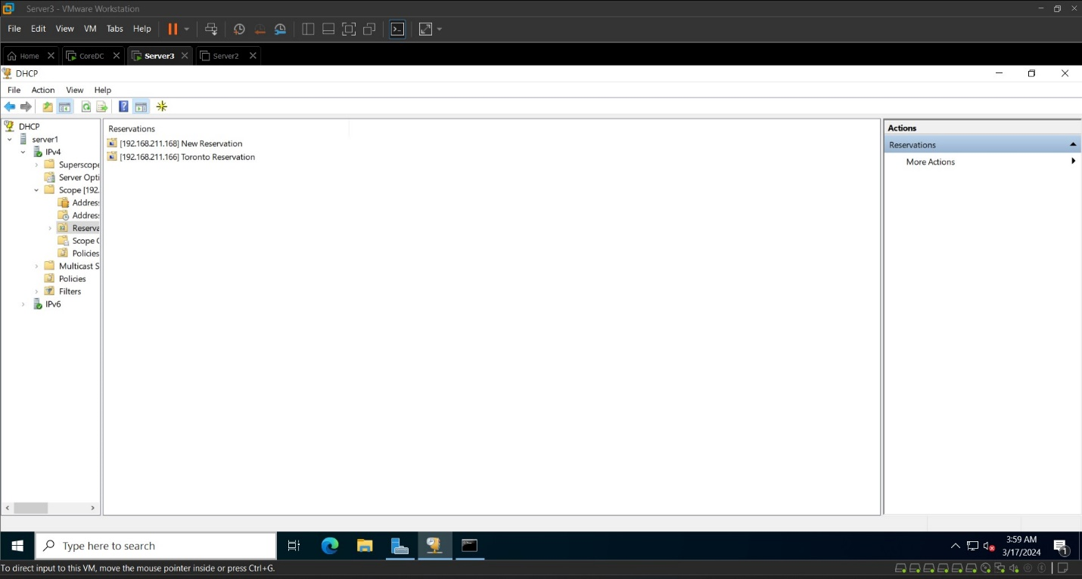

Figure 24 Reservation

## Domain DNS Server and forwarder

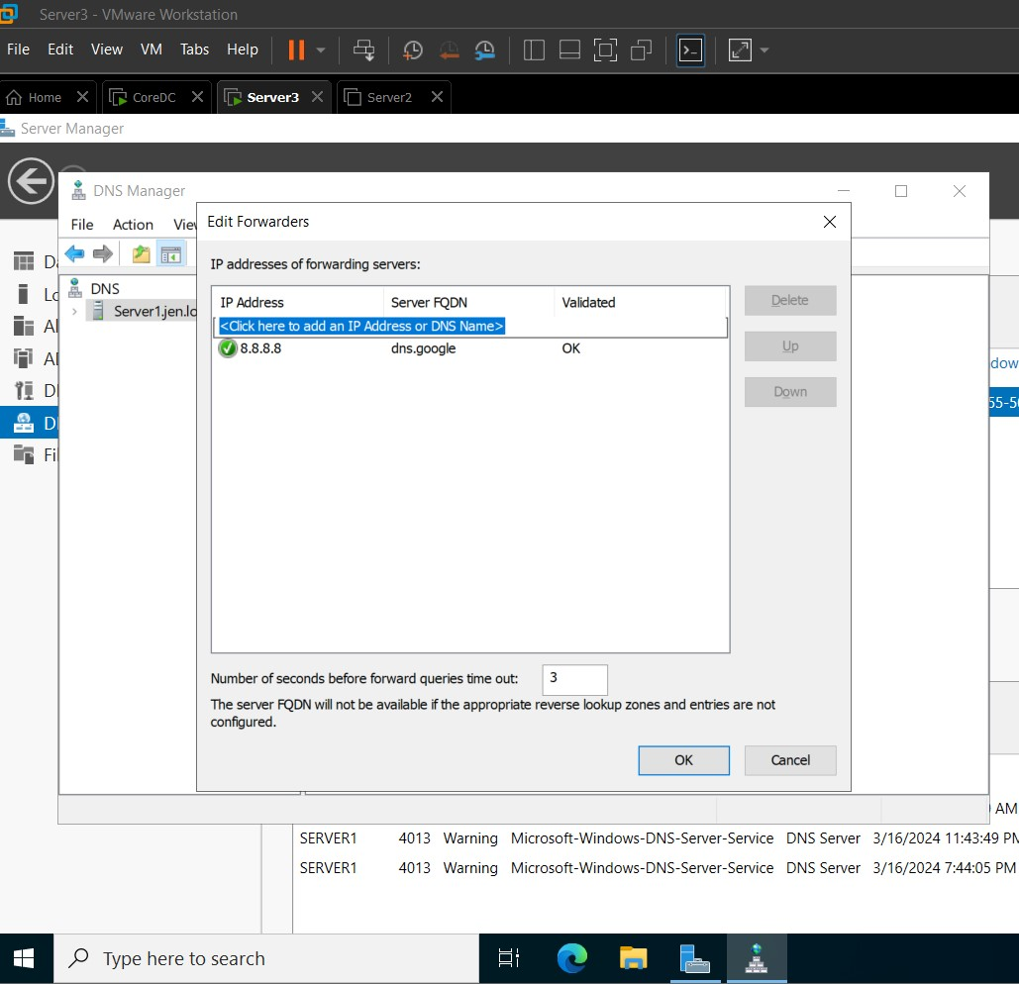

Figure 25: DNS Forwarder to 8.8.8.8

## Storage Pool and vDisk

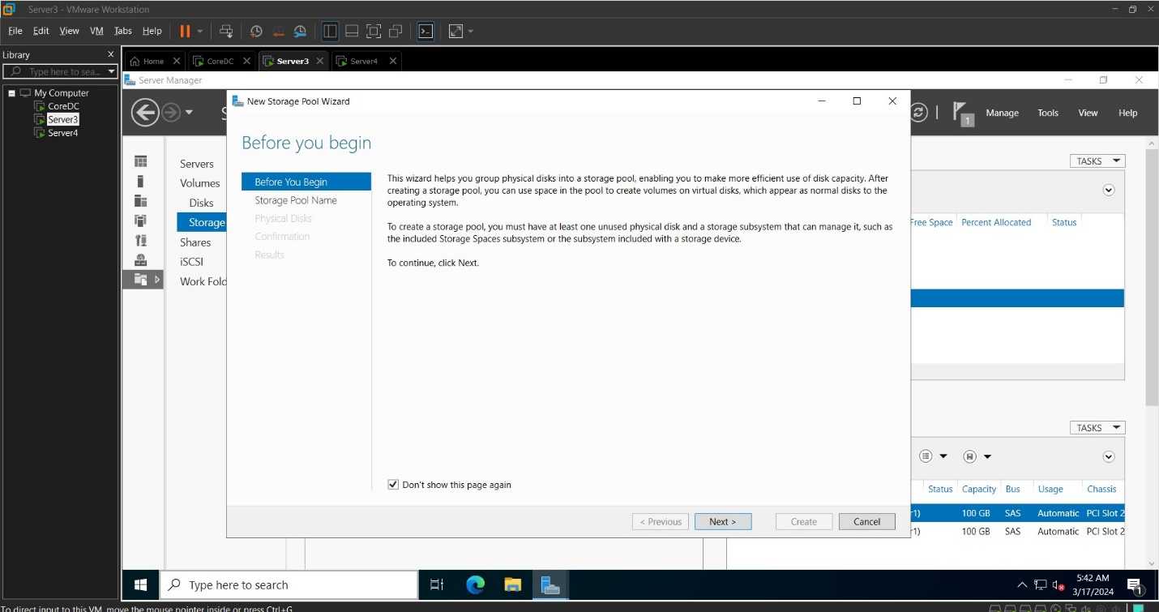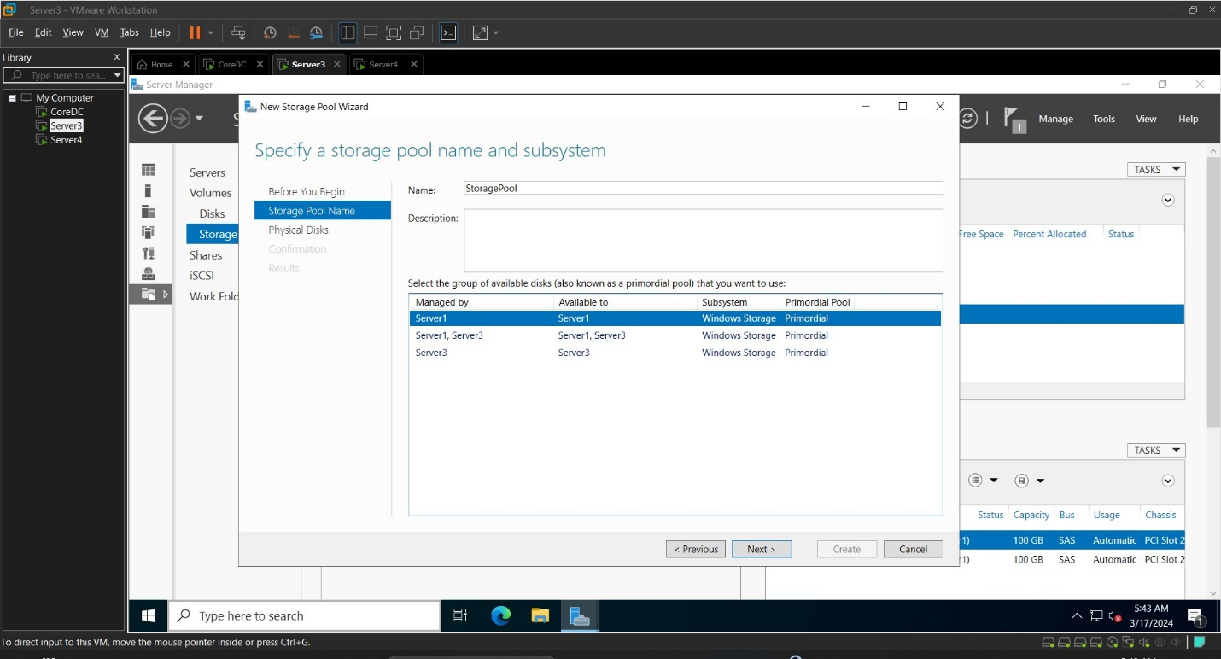

Figure 26: COnfiguring storage on Local Server

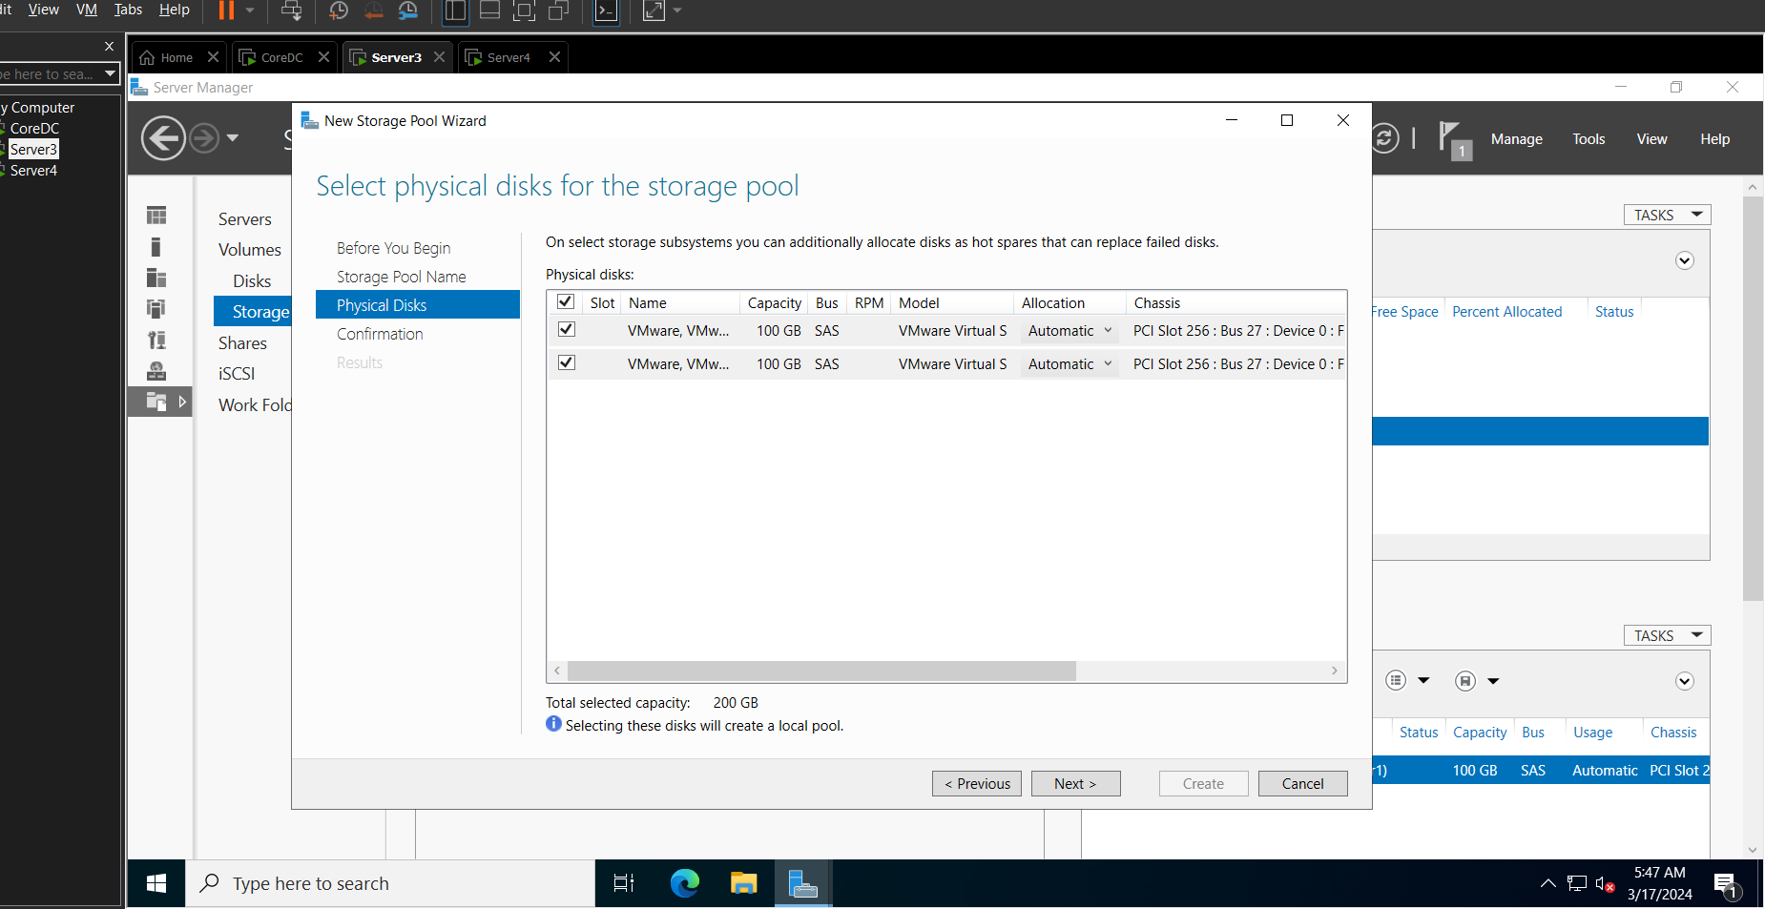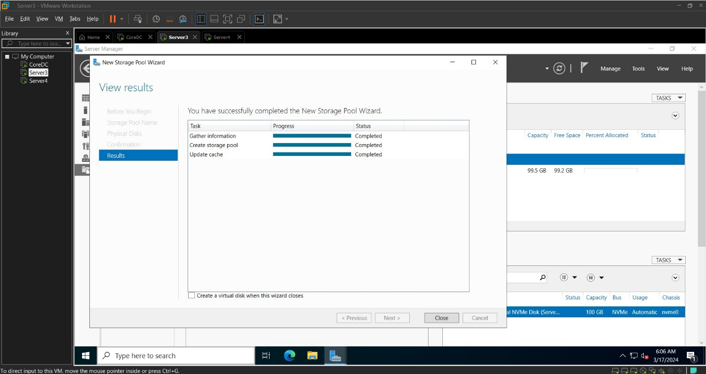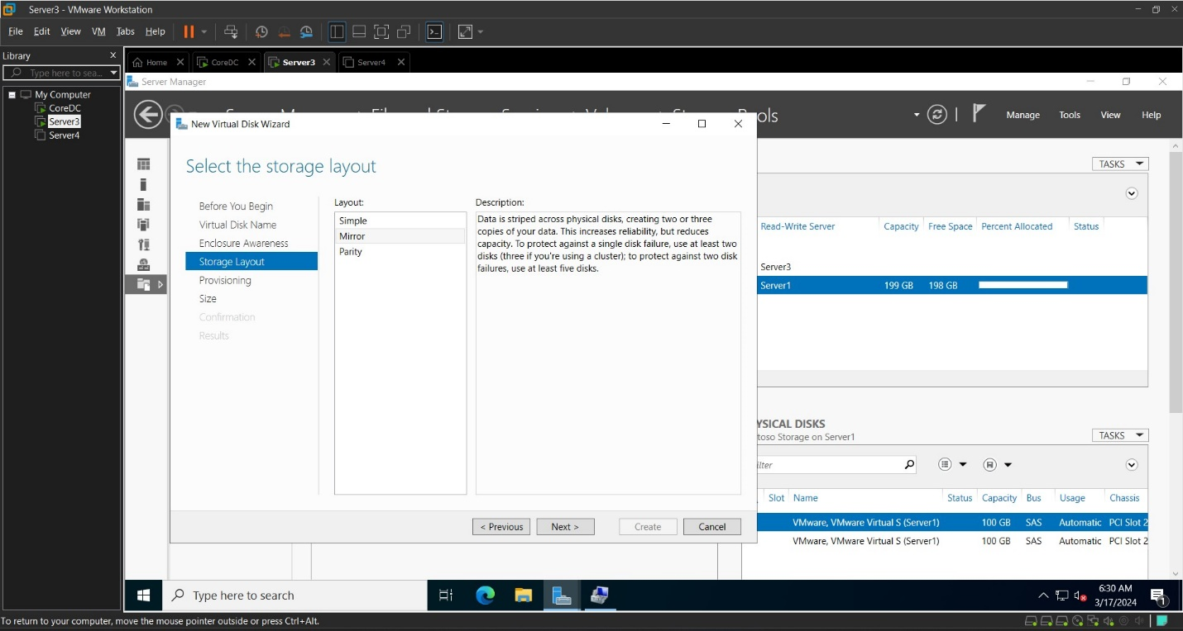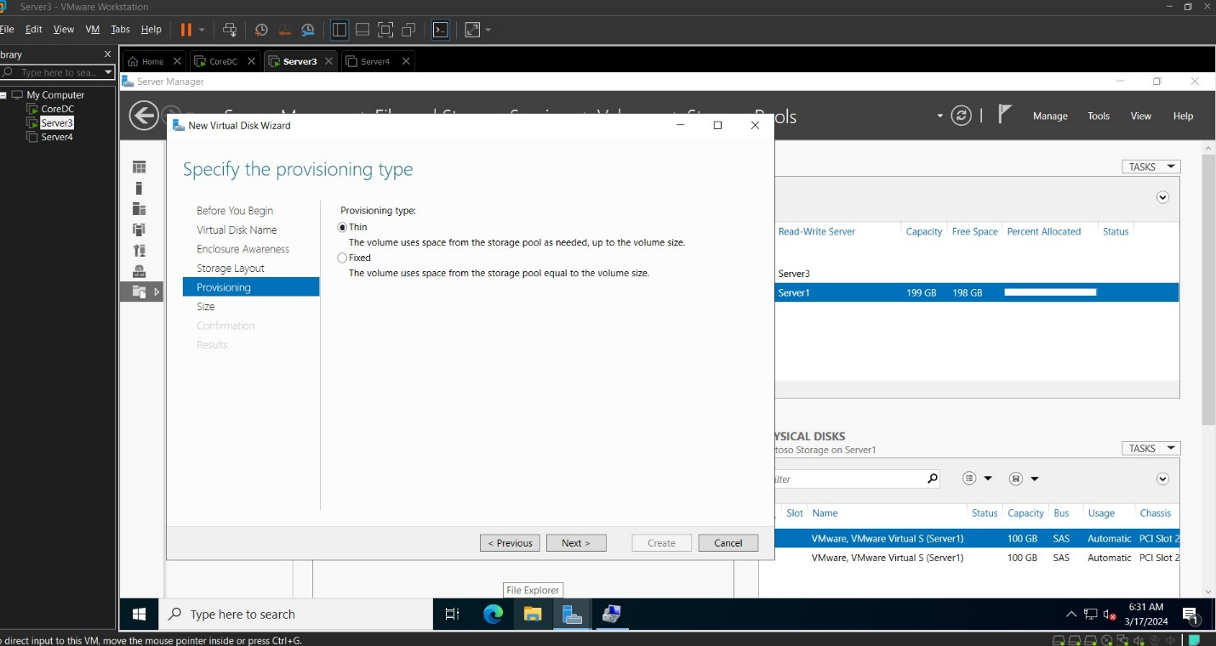

Figure 27: Configuring a Dynamic Storage for high availability

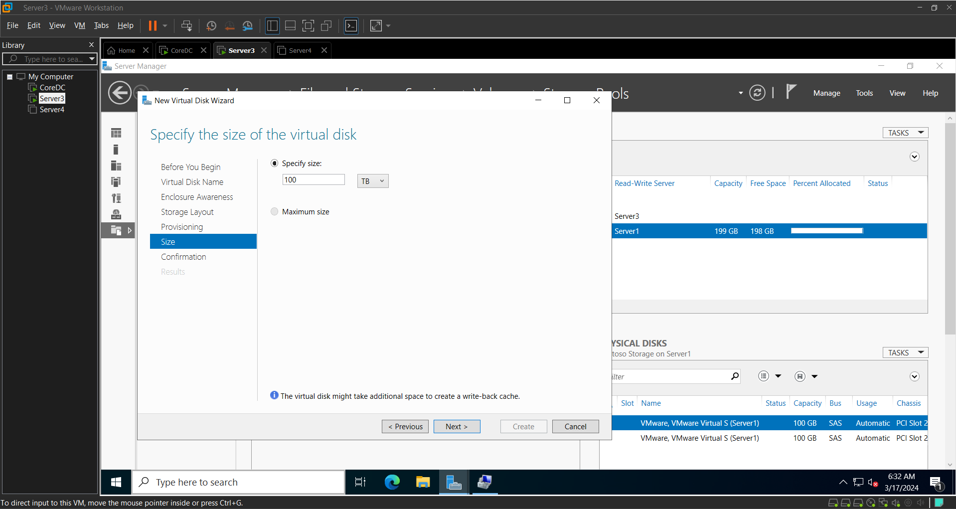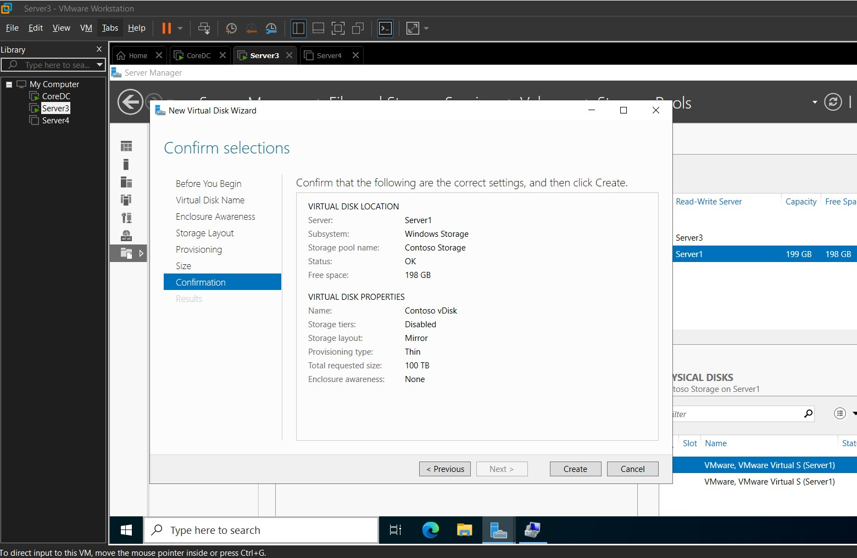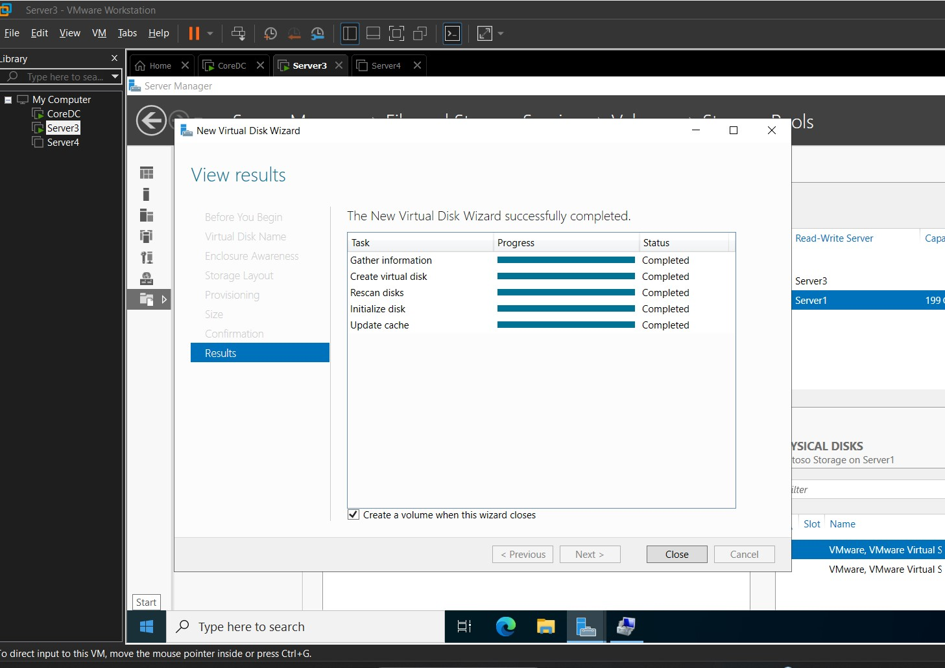

Figure 28: Creating a Virtual Disk

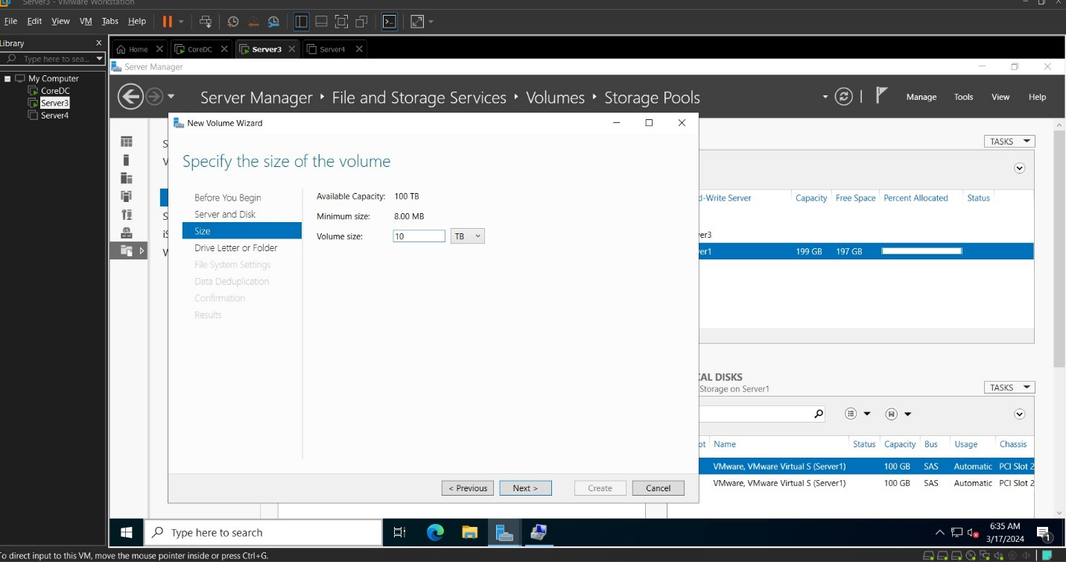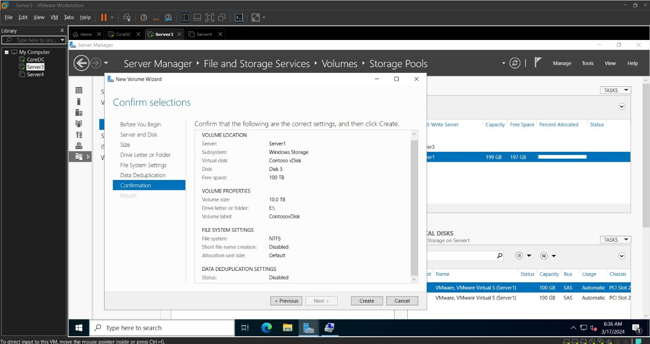

Create and Configure iSCSI on Server 2 and Attach to Server 3 (In my case it was Server 3 and Server 4)

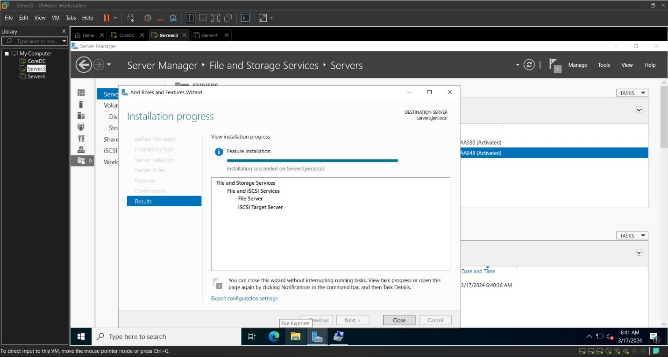

Figure 29: Install File and iSCSI Server

Follow through with wizard prompt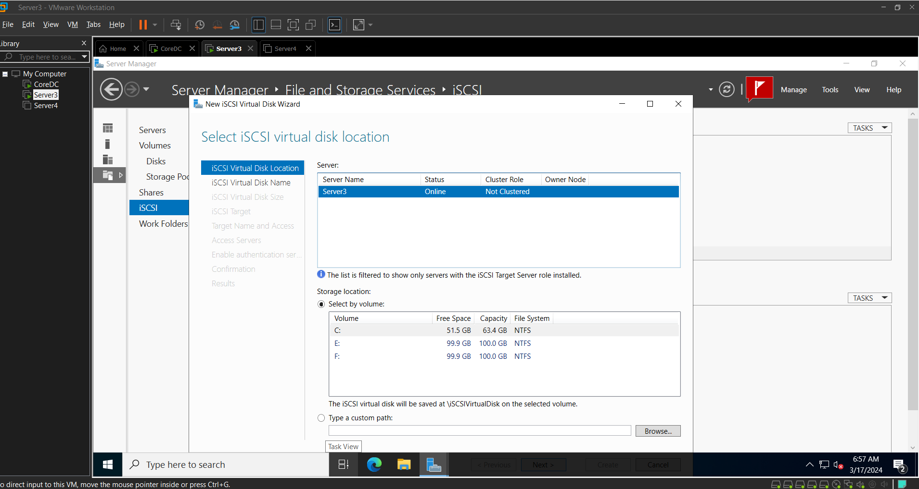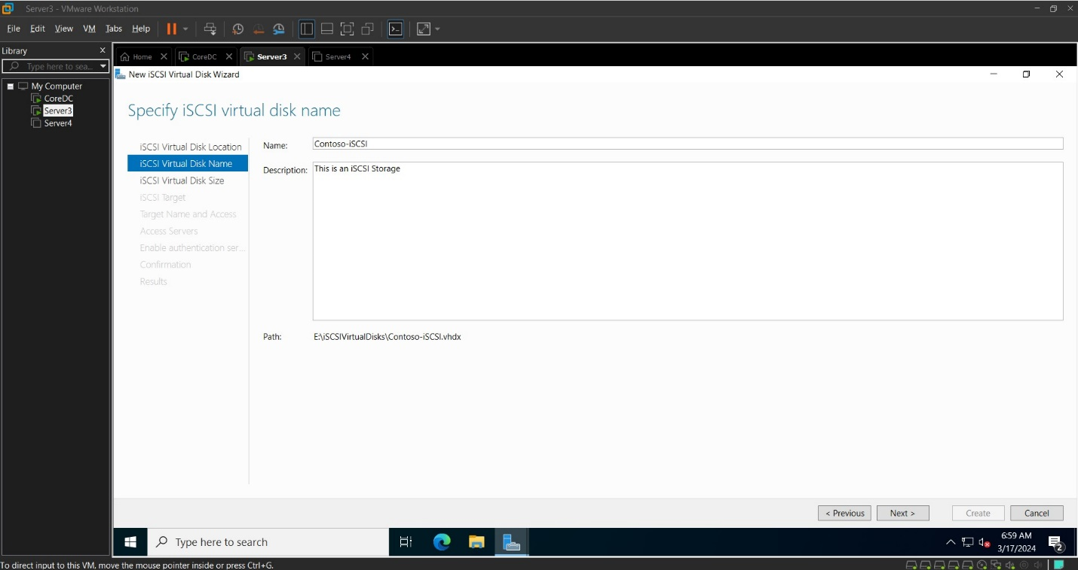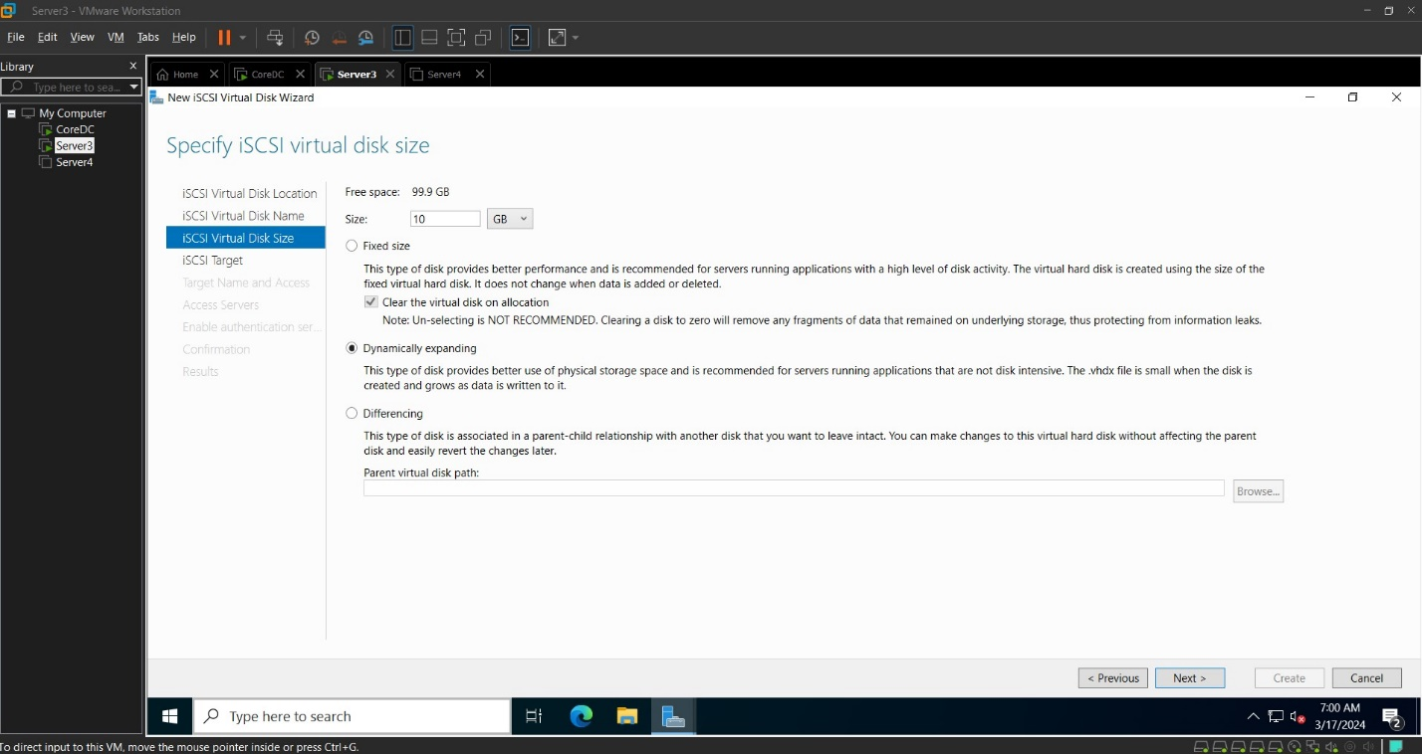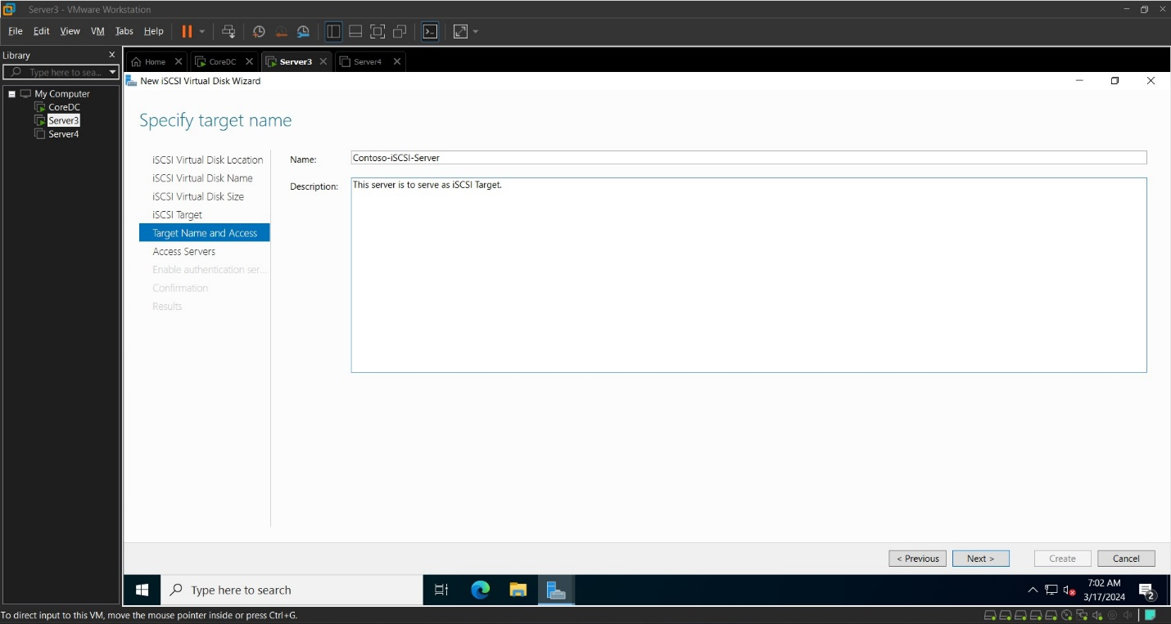

Through iSCSI initiator tool on Server 4’s Server Management, retrieve the IQN and add to Server 3 to confirm connection to iSCSI target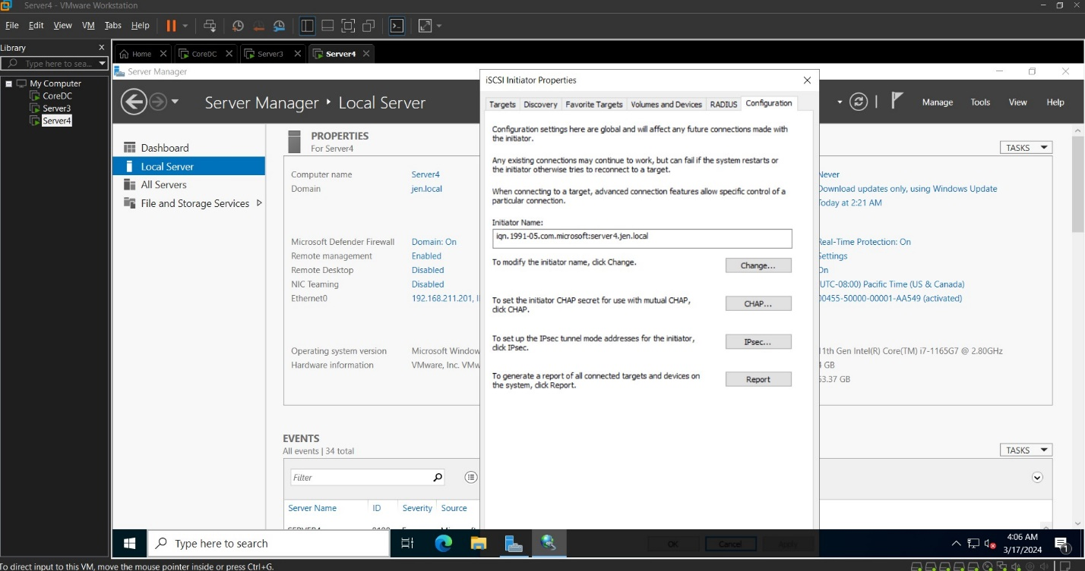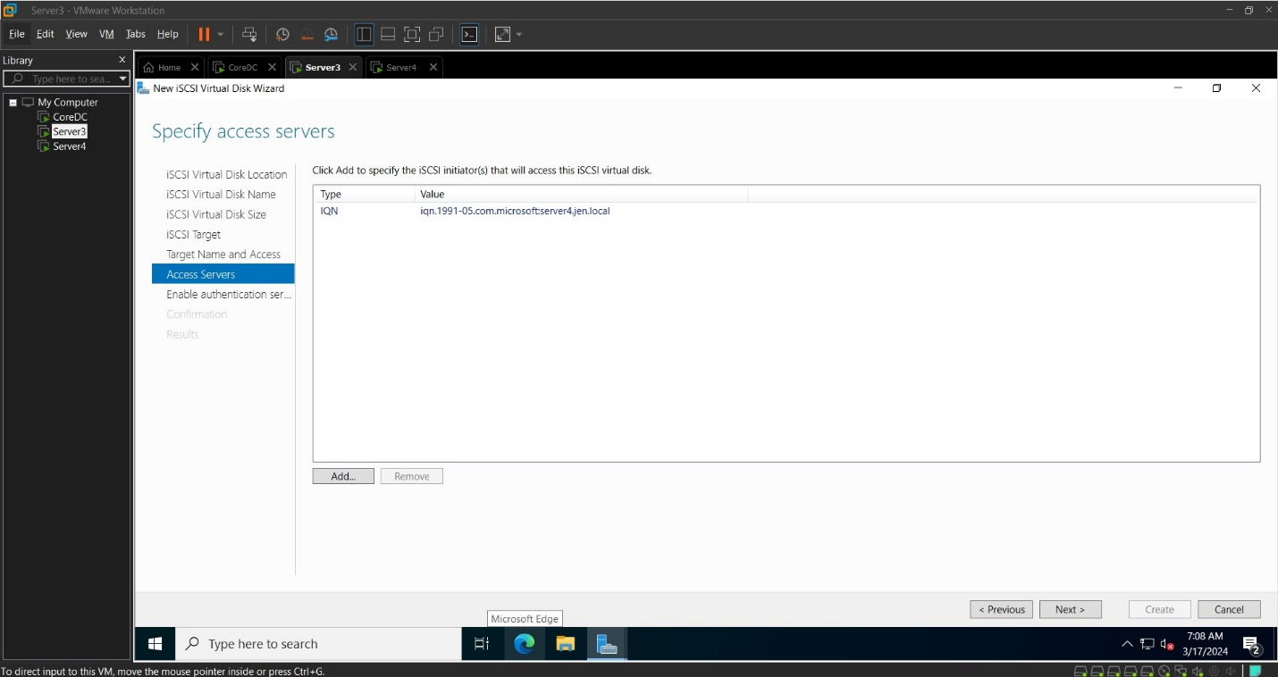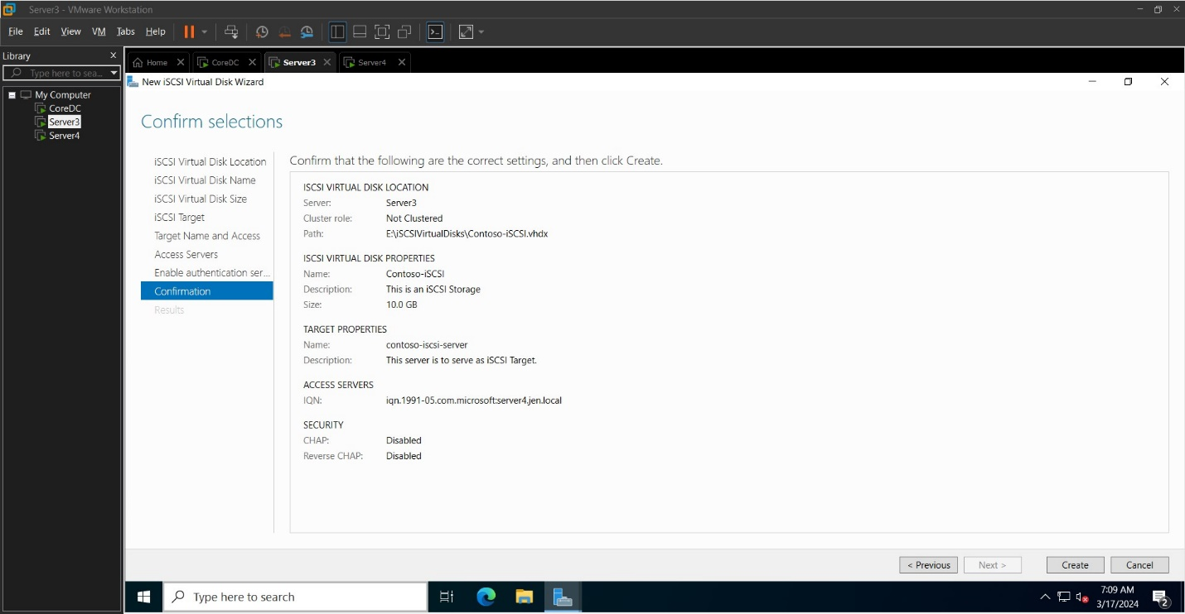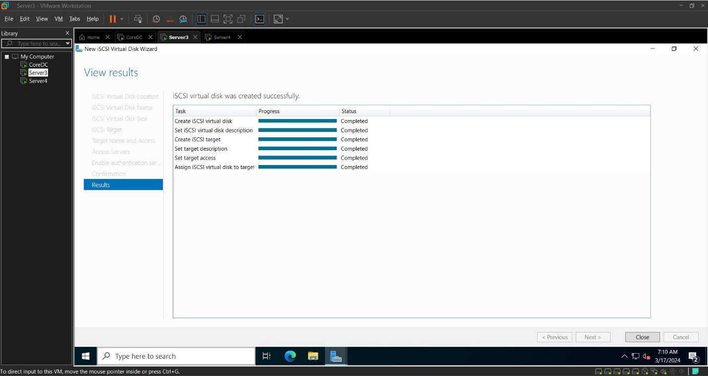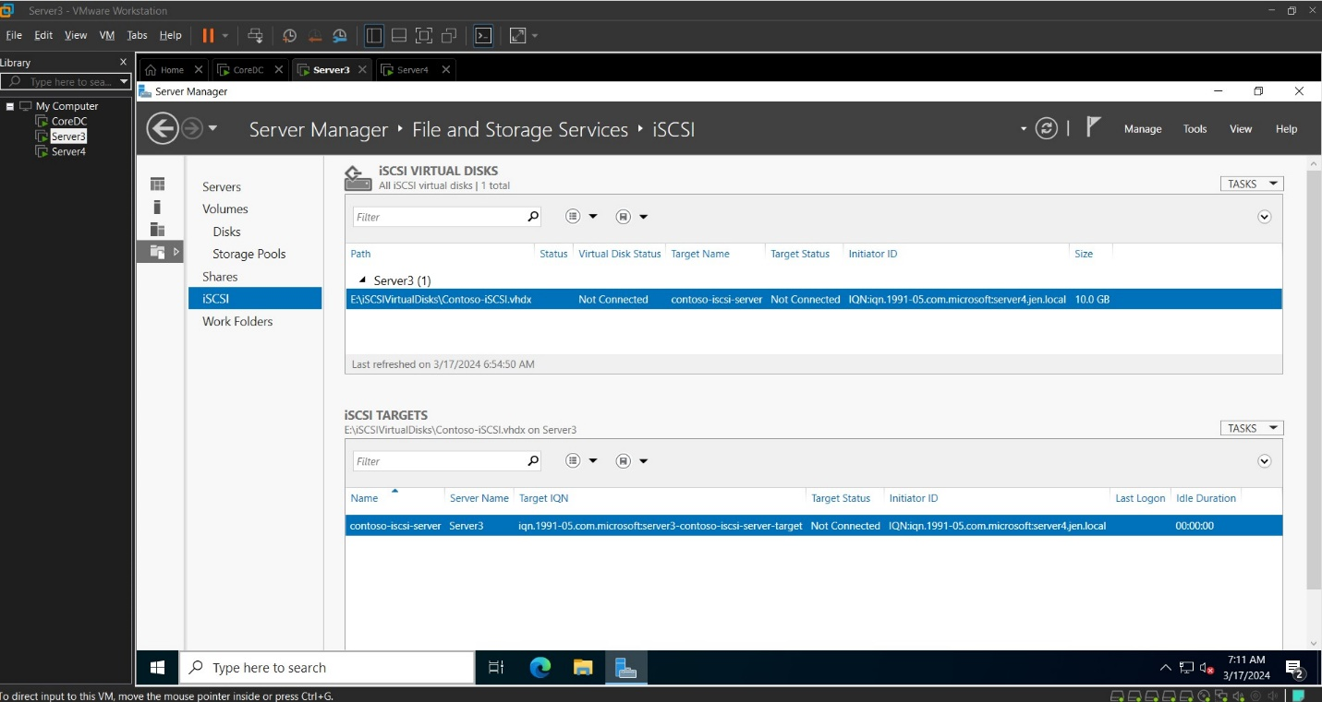

HyperV (It’s a nightmare)

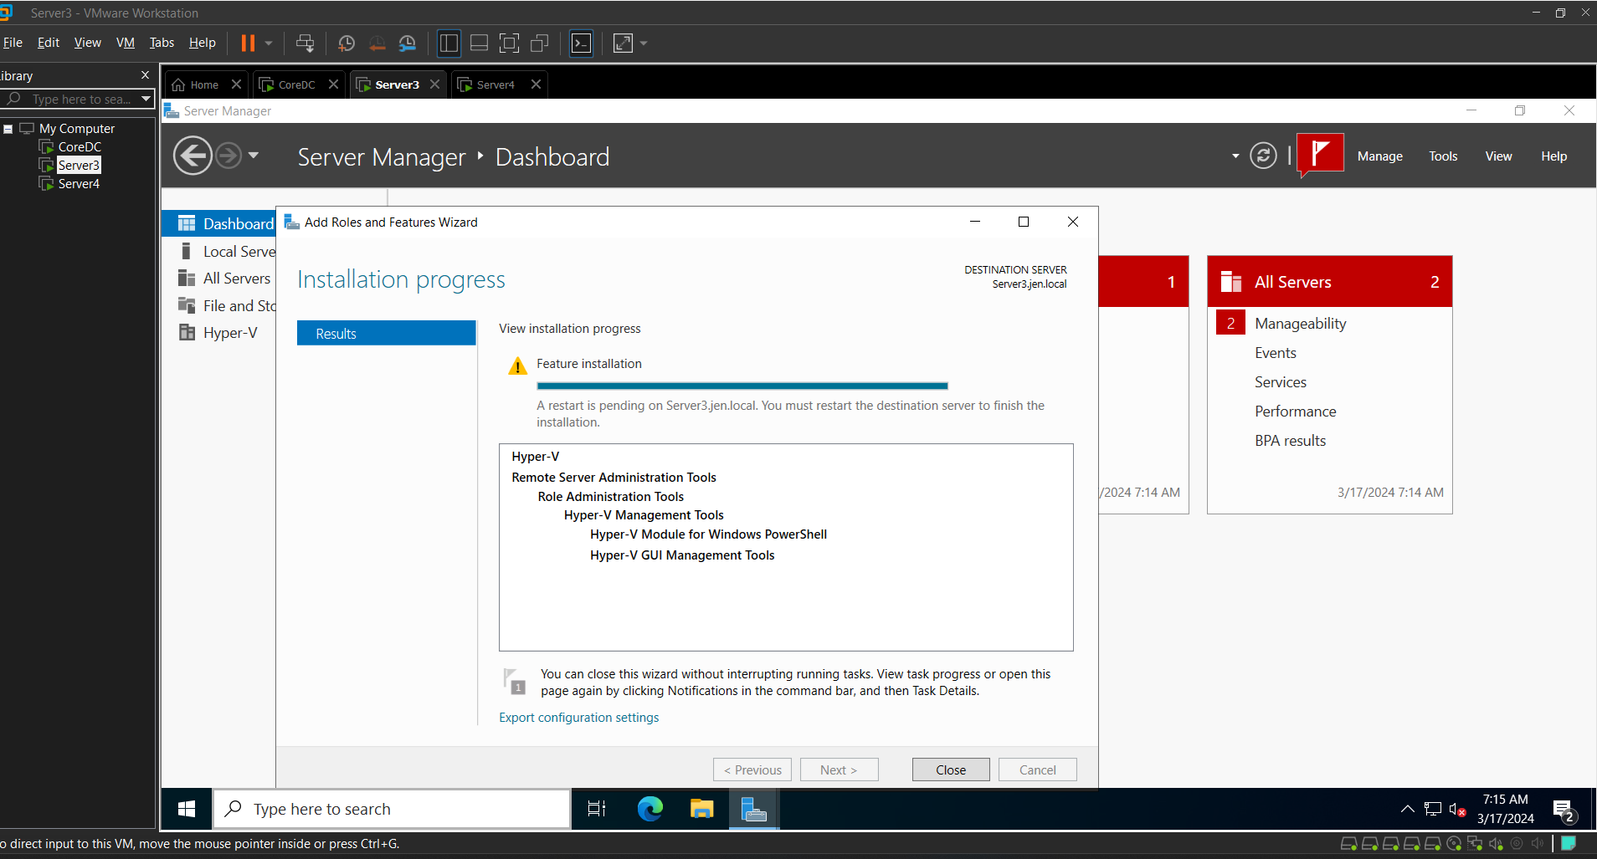

Prepare disk for HyperV environment

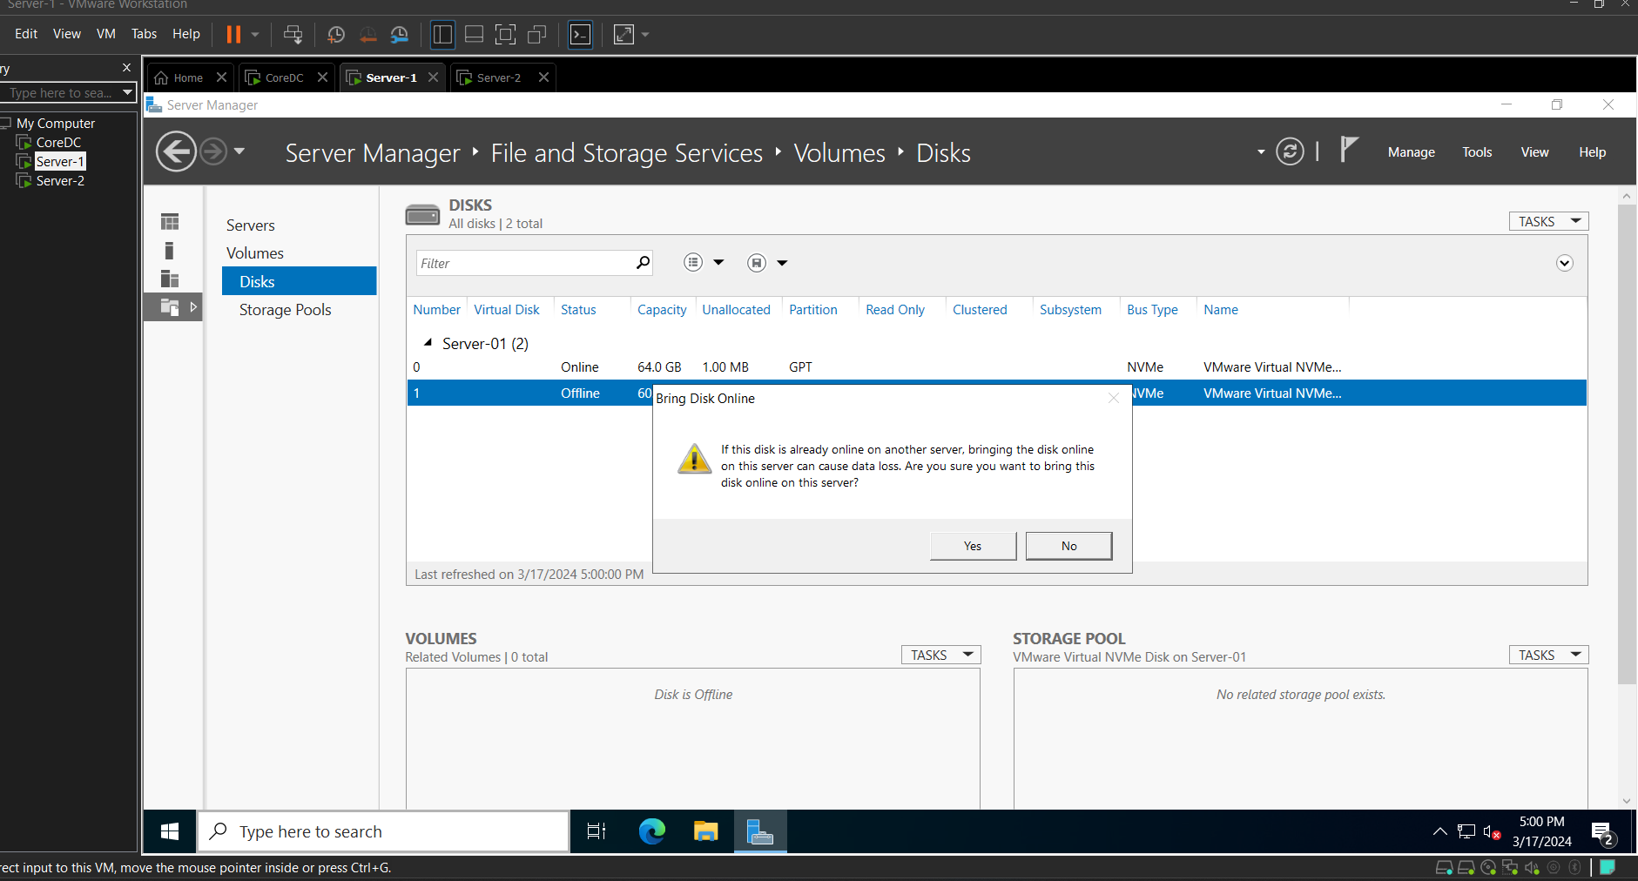

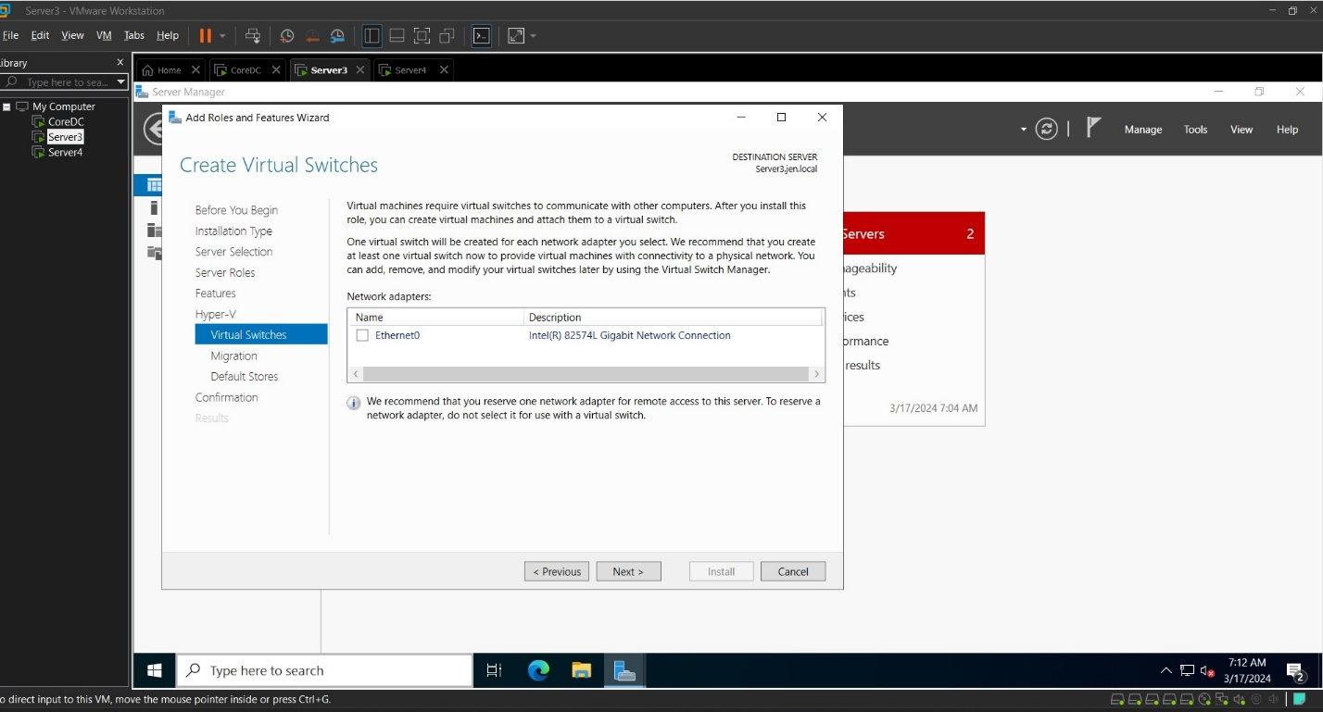

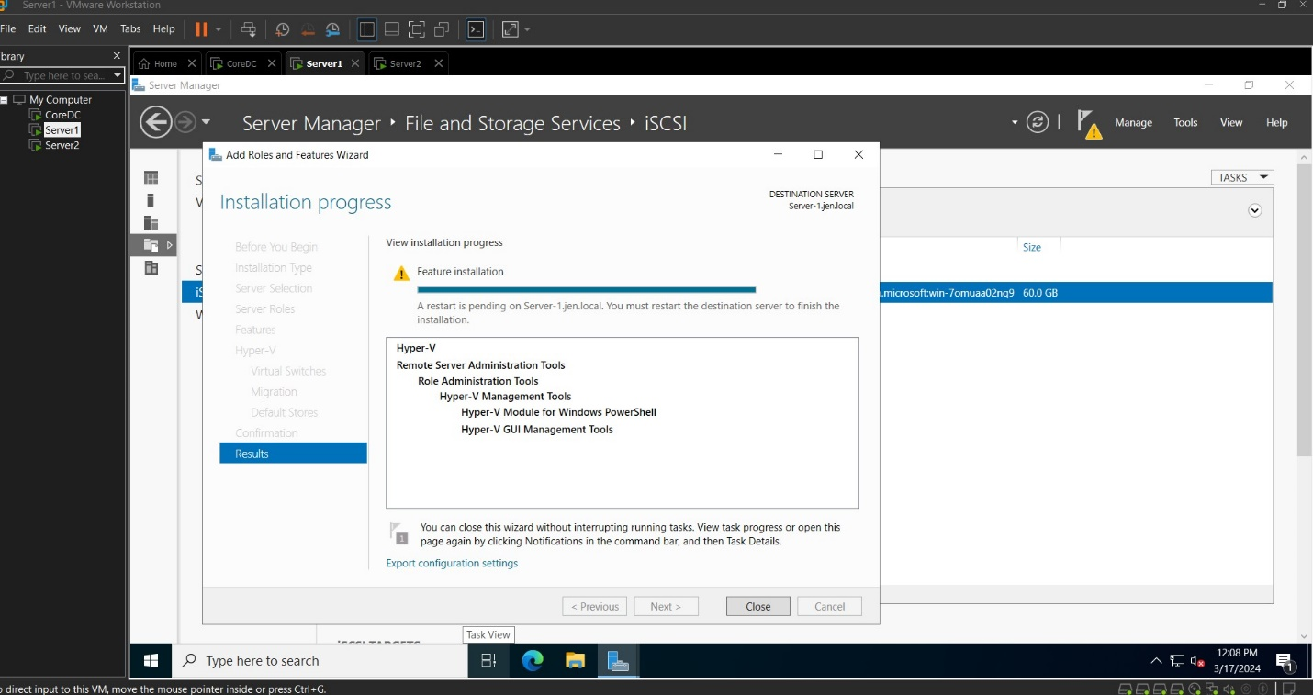

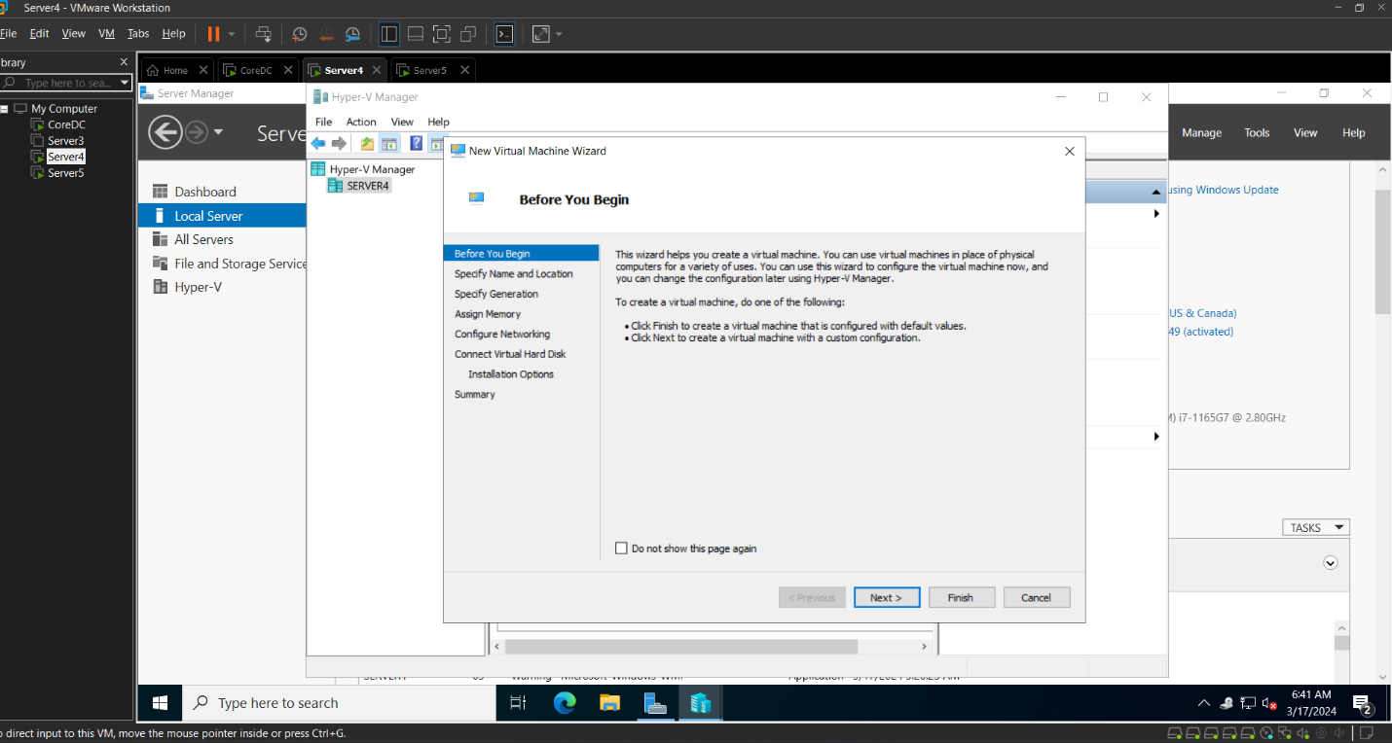

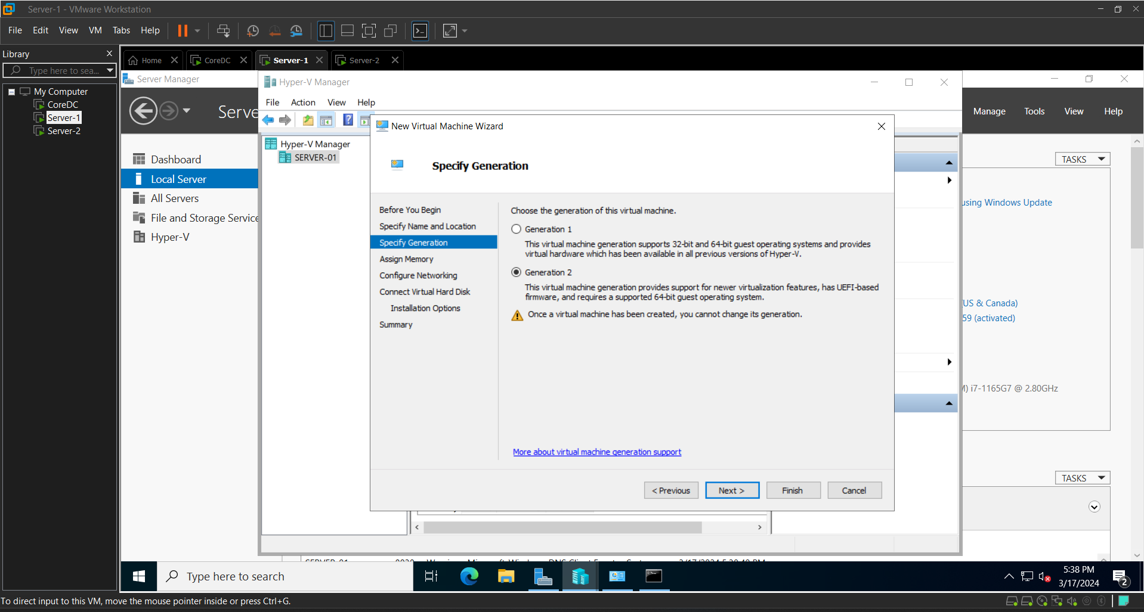

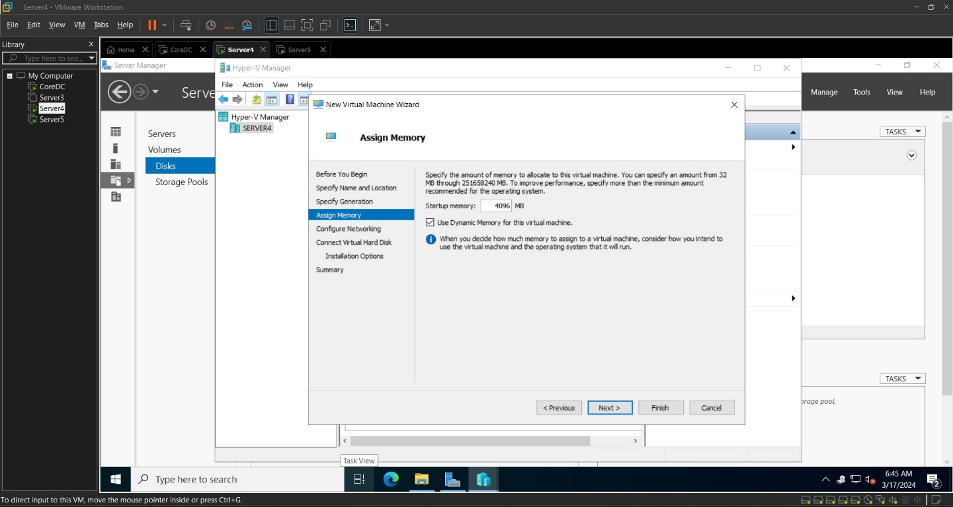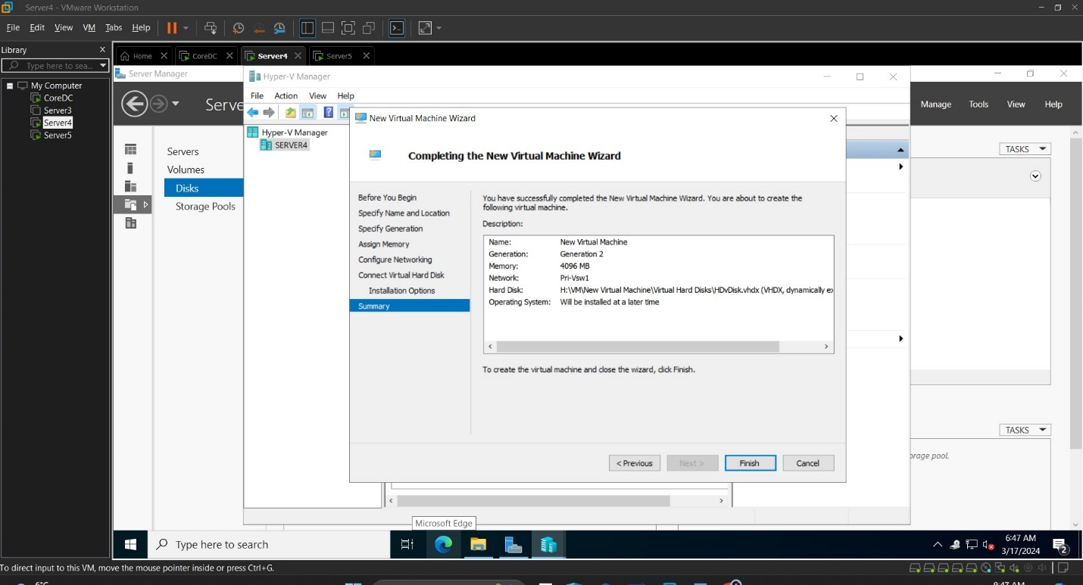

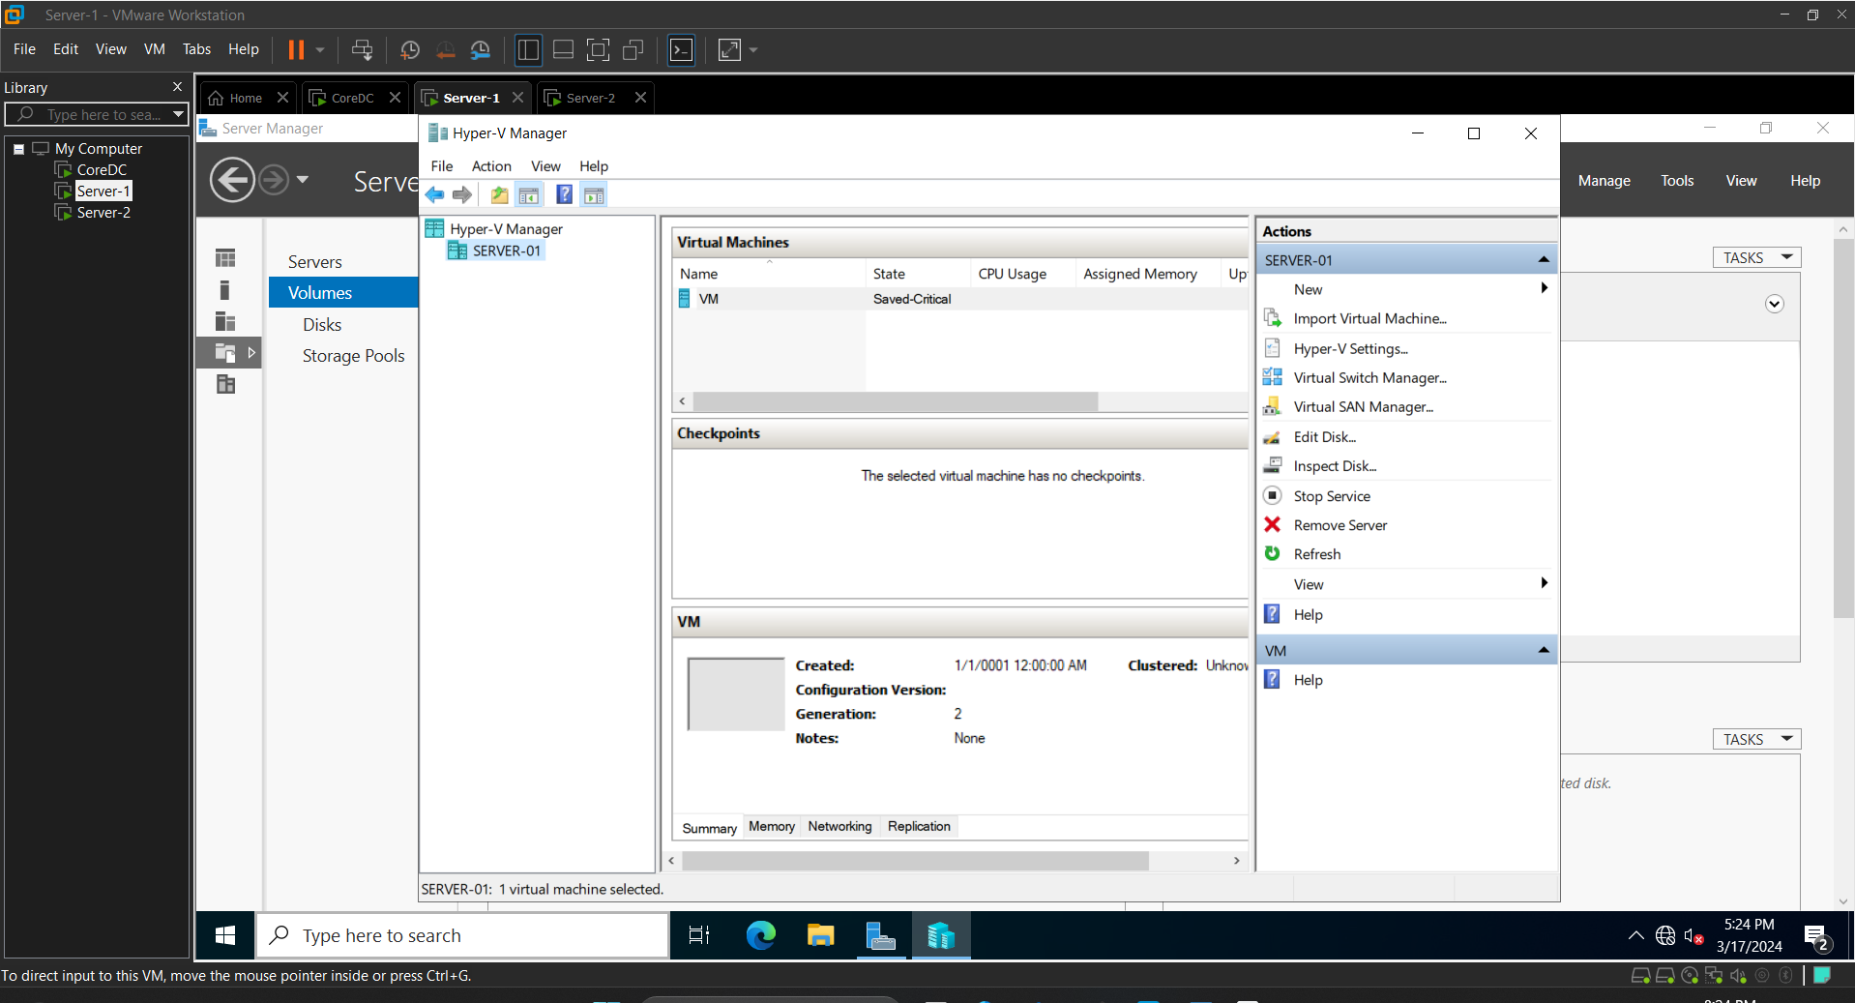

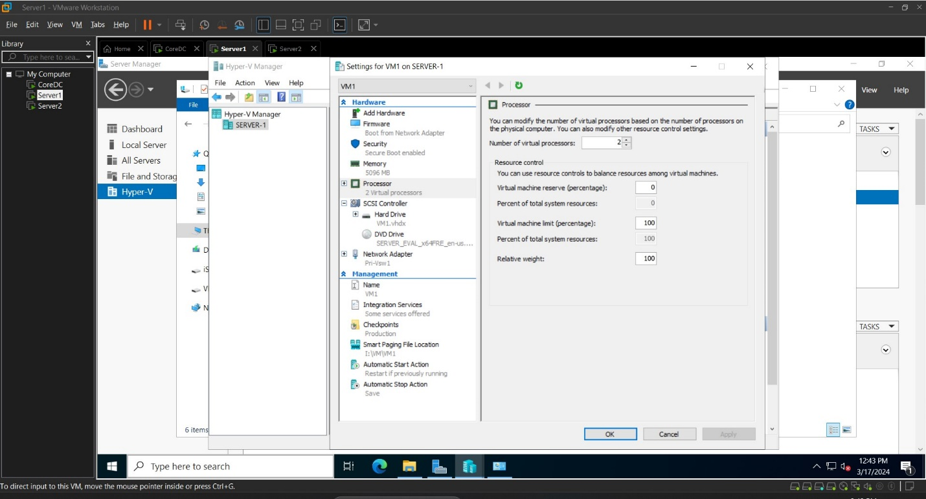

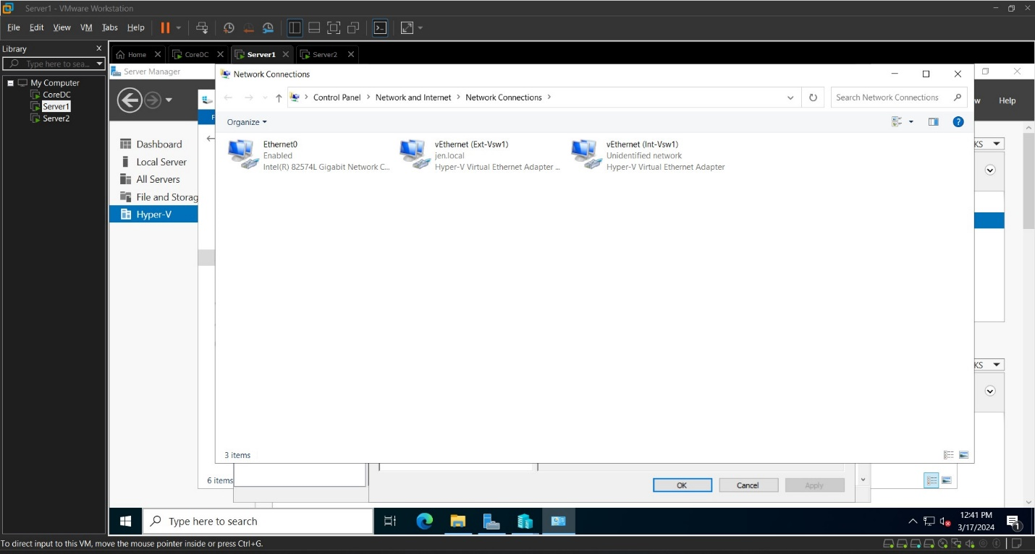

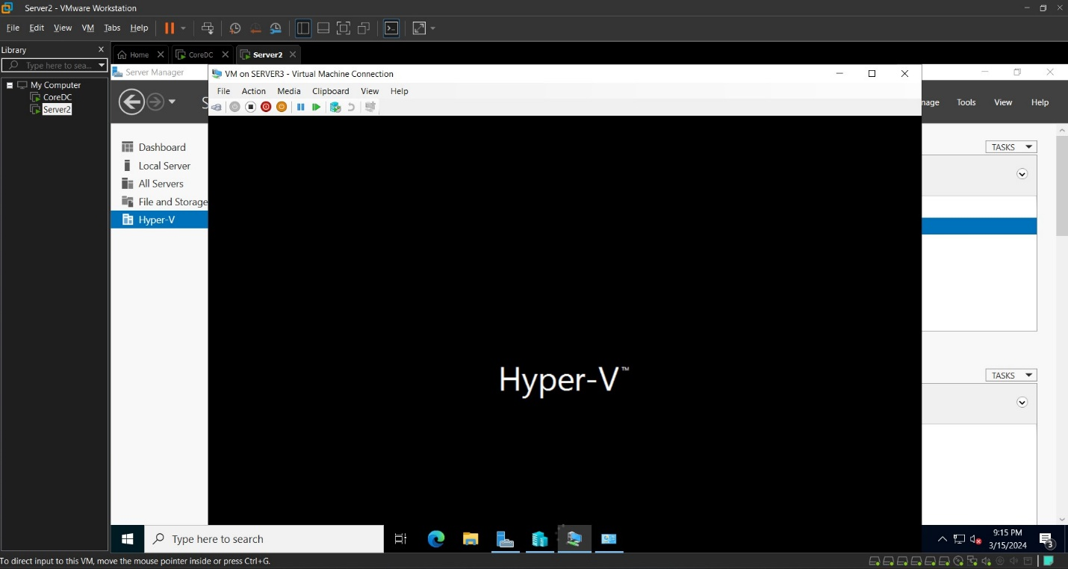

WSUS Configuration

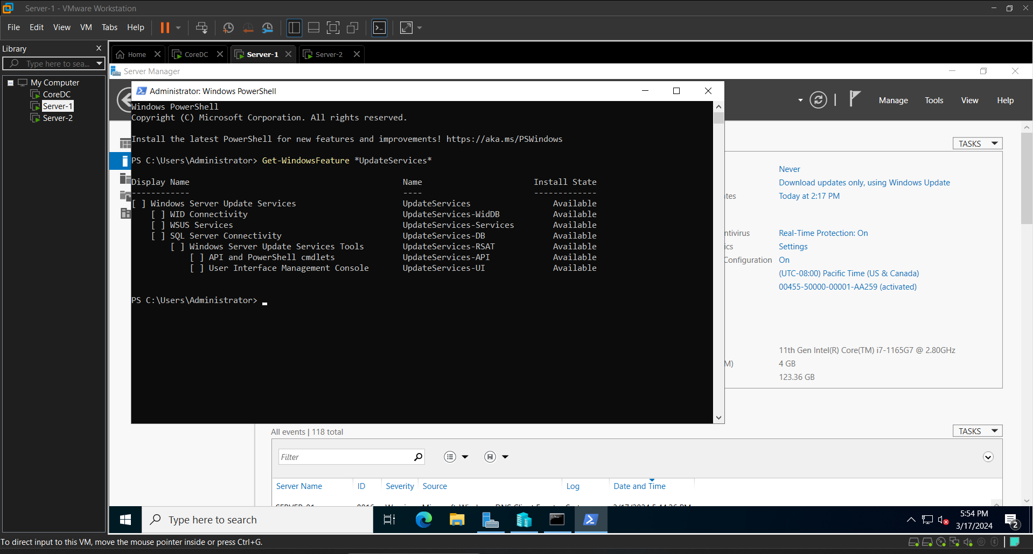

Figure 30: Installed WSUS on Server2 for GUI

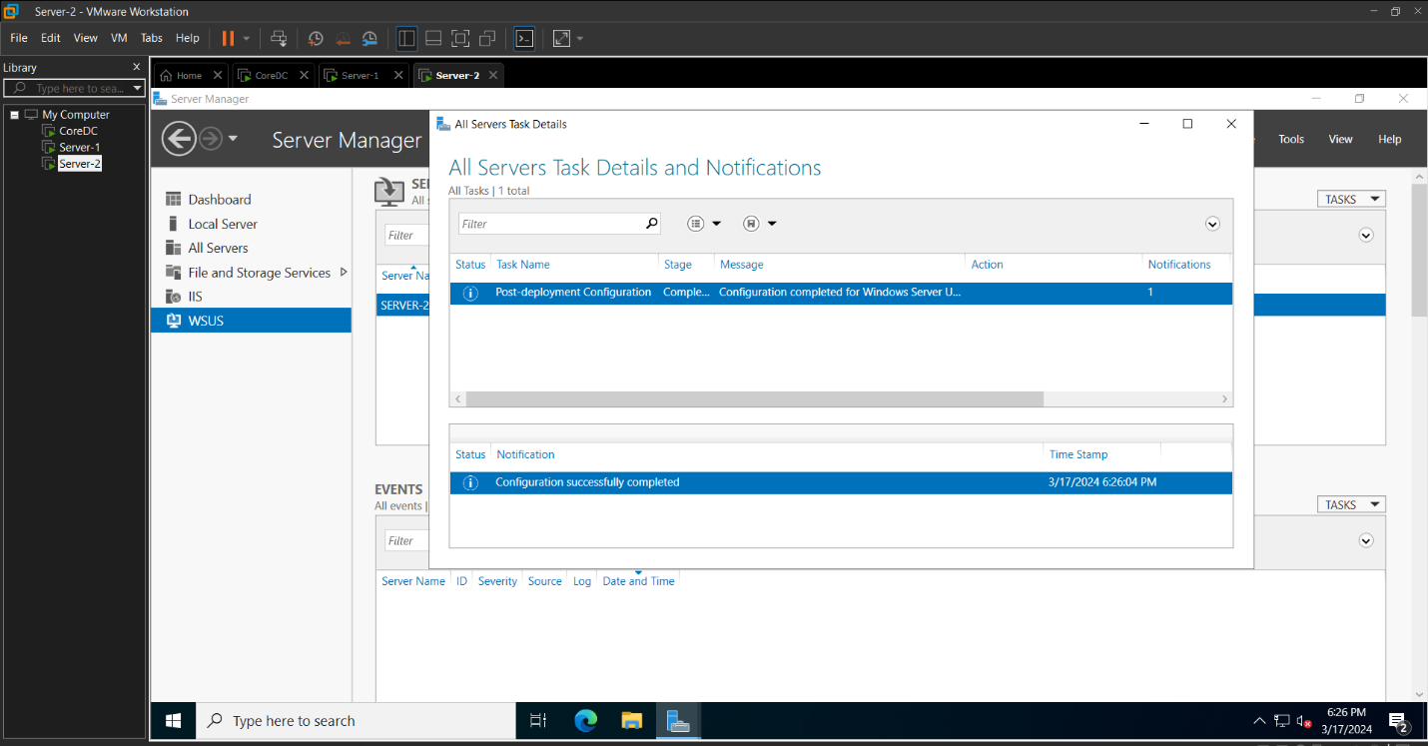

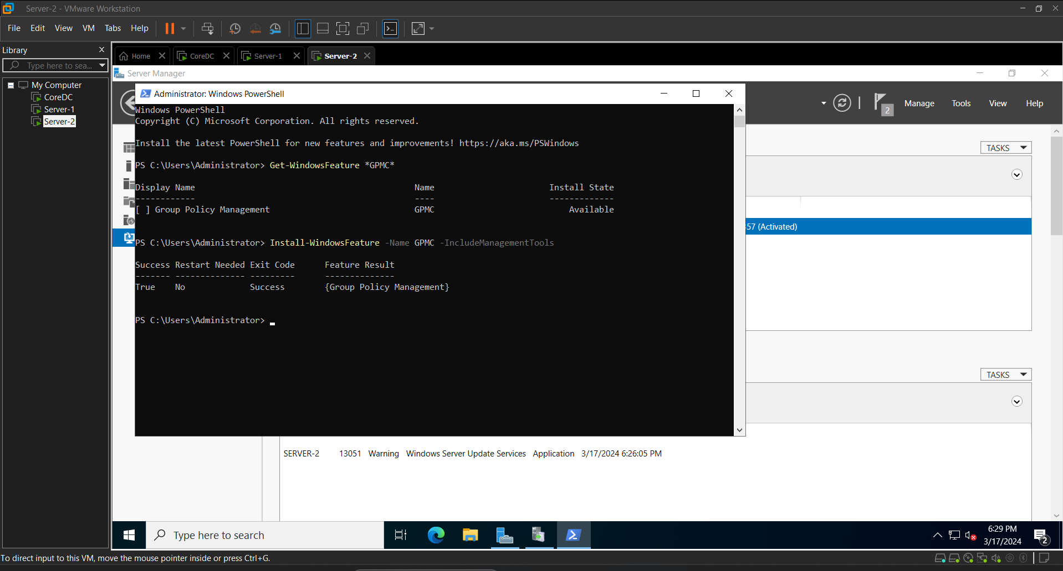

Figure 31: Group Policy Management Console Installed

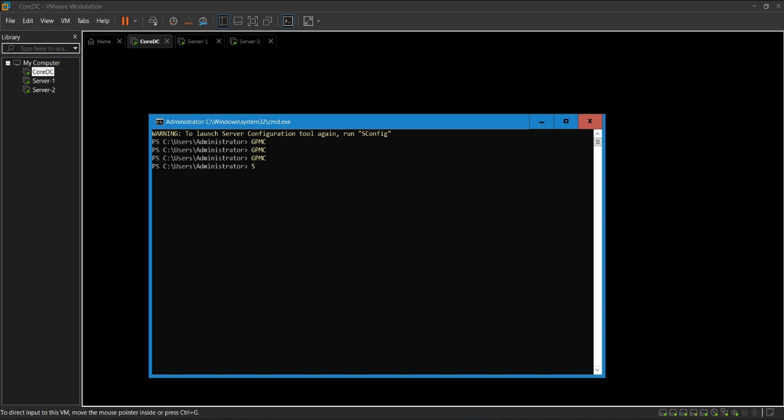

Figure 32: GPMC LAUNCHED from Domain Controller

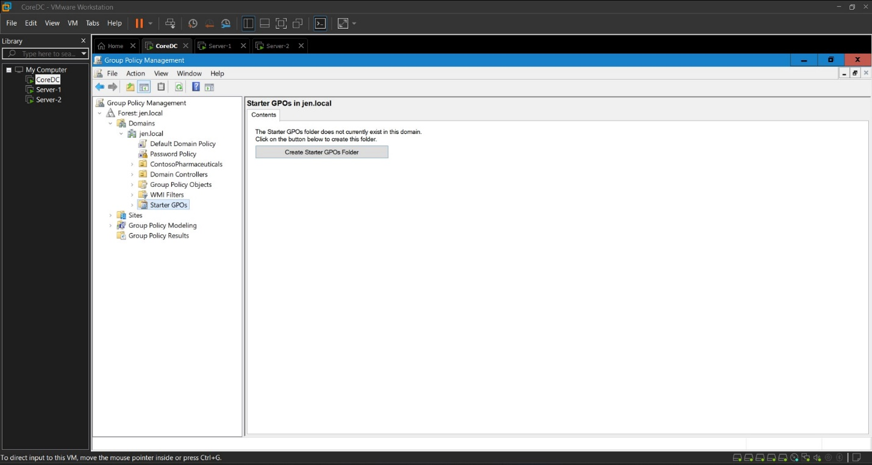

Figure 33 Navigating towards Windows Update on Group Policy Object

